

DXC RealTime Projects

AZ-900, DP - 203



June 10, 2022

[DXC]

Name: Nandipati Lakshmi Sunitha

Reg No: DXC262AB1219

**Project1 Name: Smart Vehicles**

Date: 10.06.2022

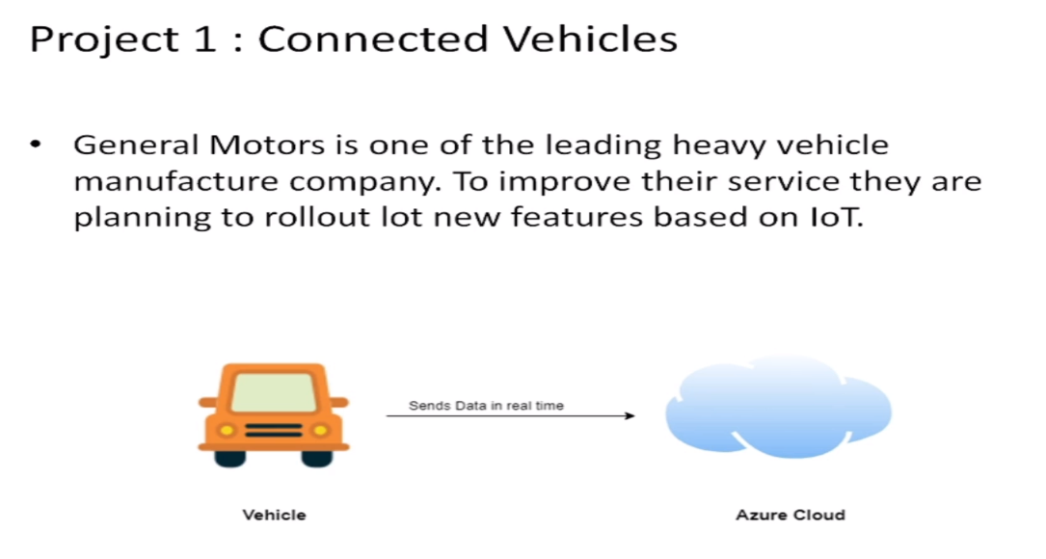

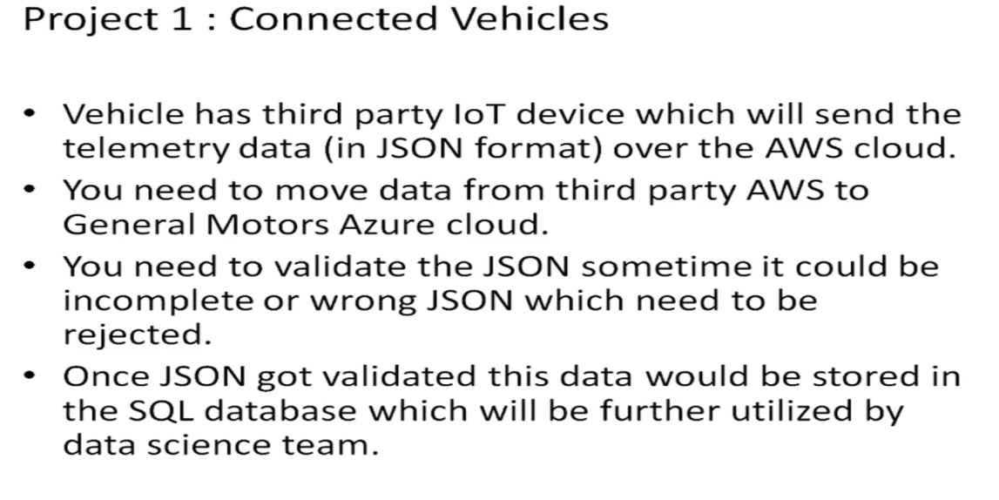

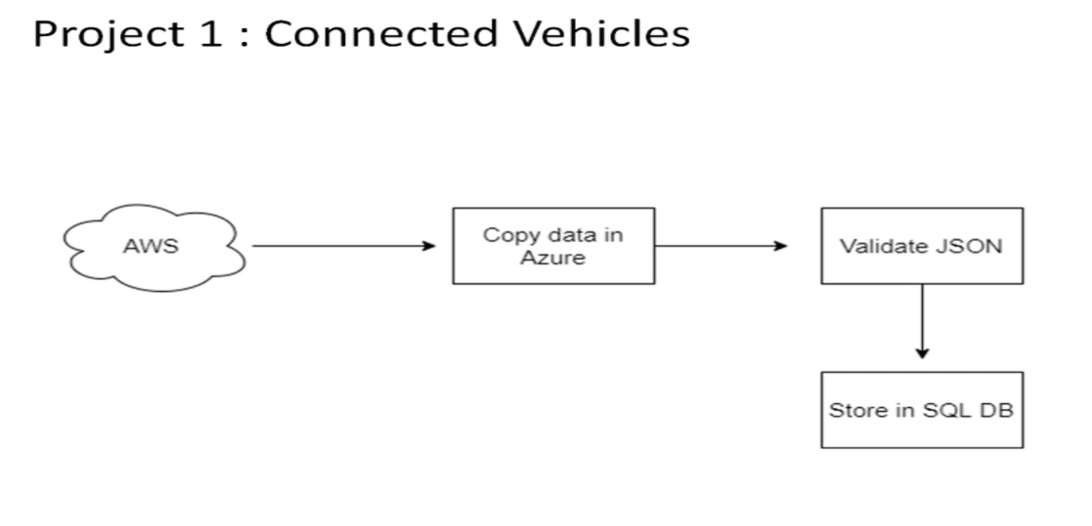

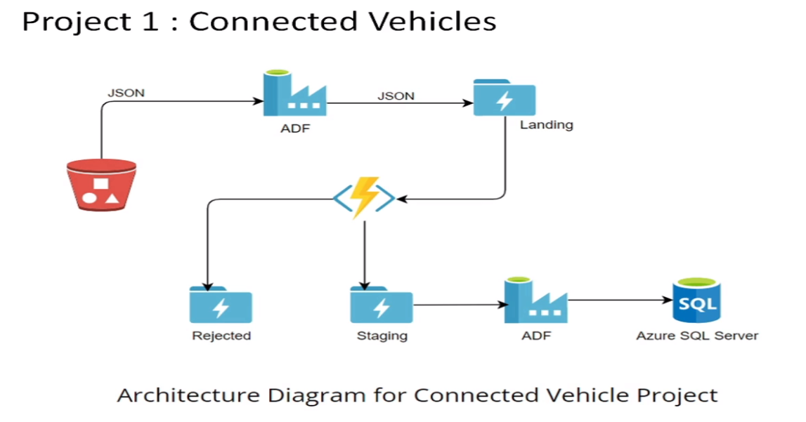

Practical Lab: Create **Azure Data Factory** Account For Data pipelines

Step 1: Go to Azure account and go to create a resource and then search on Data Factory.

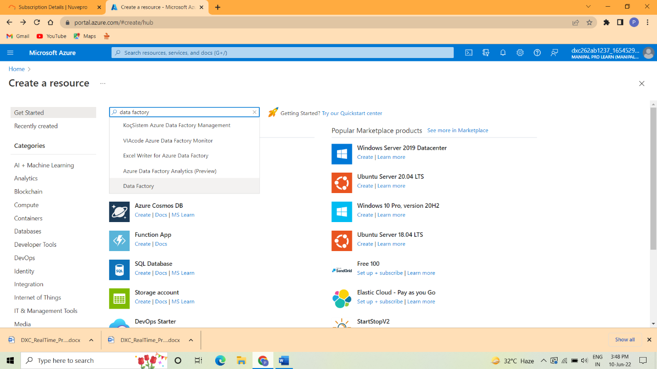

Step 2: Click the Create button.

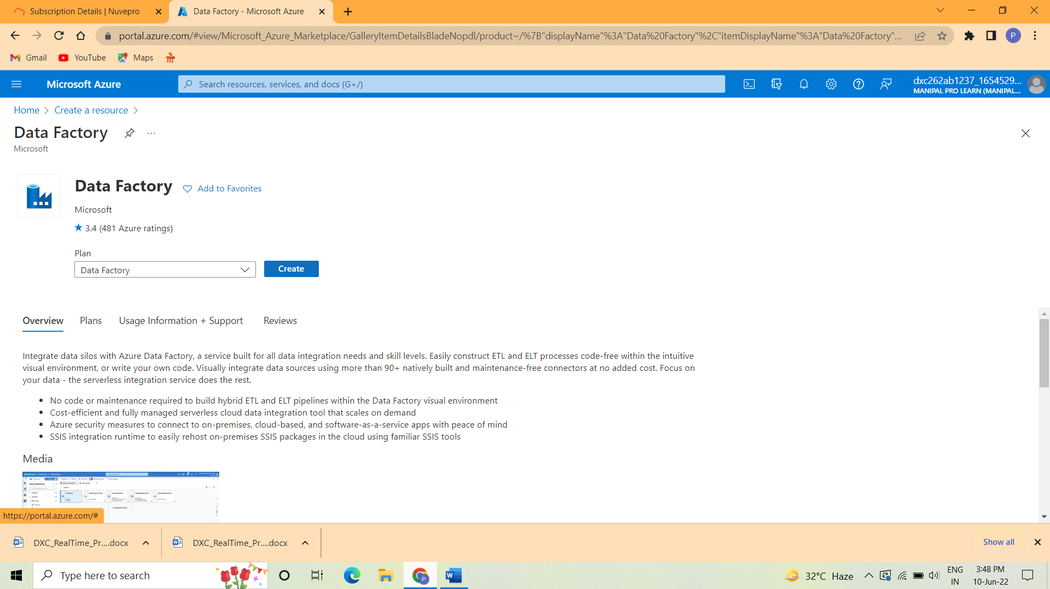

Step 3: In the Basic tag fill the subscription and instance details. And then click next button.

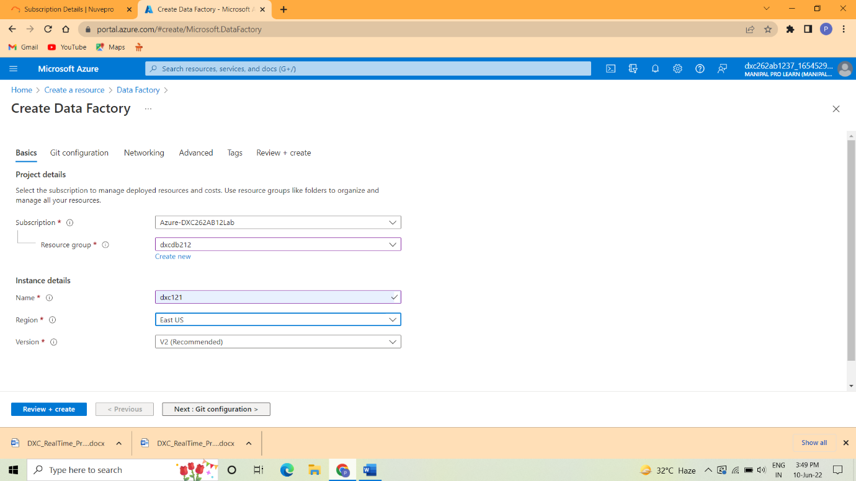

Step 4 : Go to Git configuration and then select configure Git

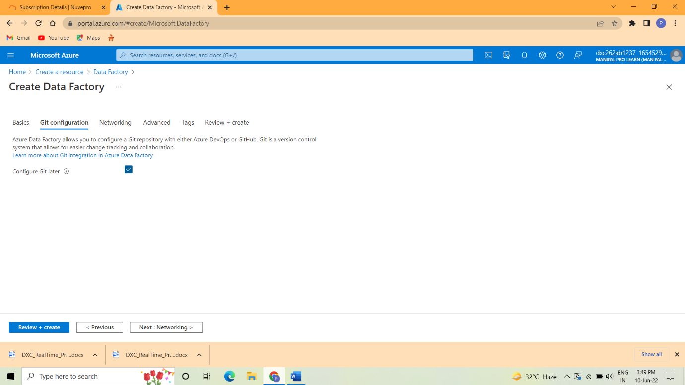

Step 5: Click Review+create button

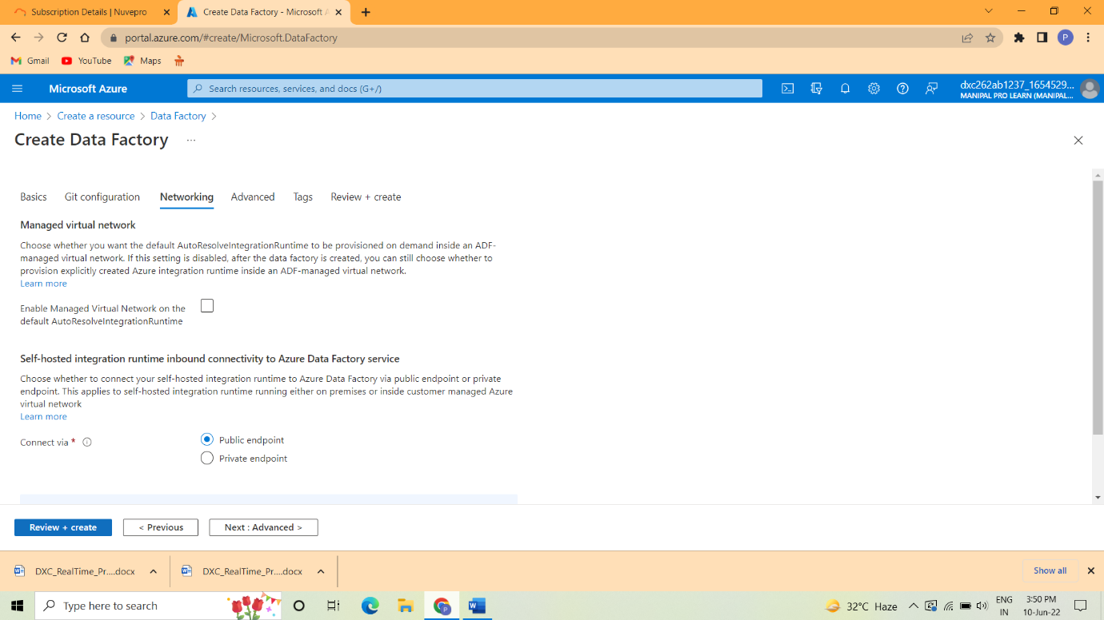

Step 6: After validation is passed click create button.

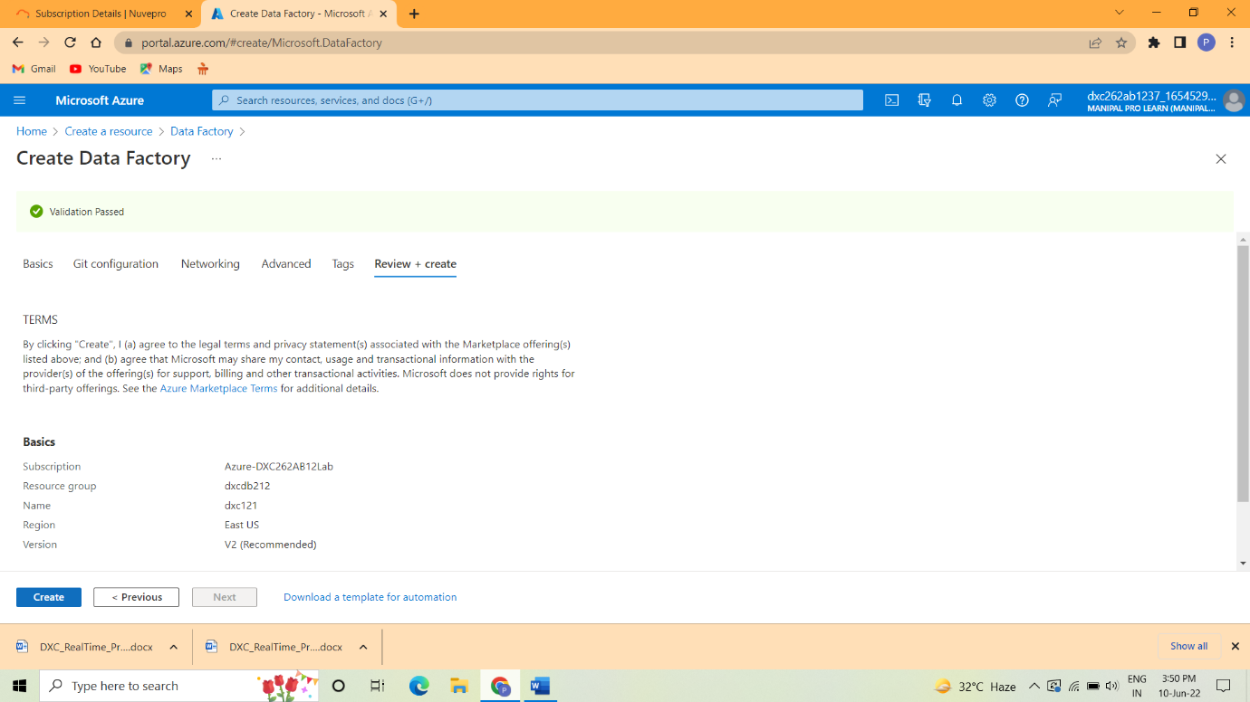

Step 7 : The deployment is completed.

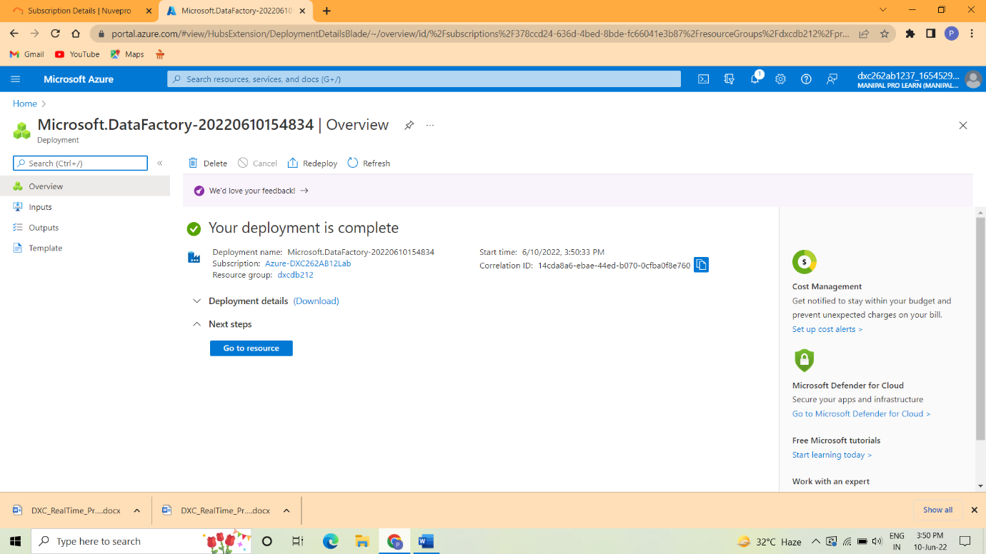

Step 8: After deployment is complete go to resource group and then Open Azure Data factory Studio.

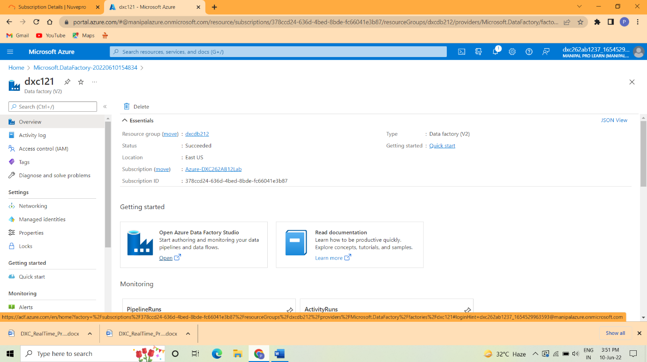

Step 9: Finally the Data Factory is created successfully.

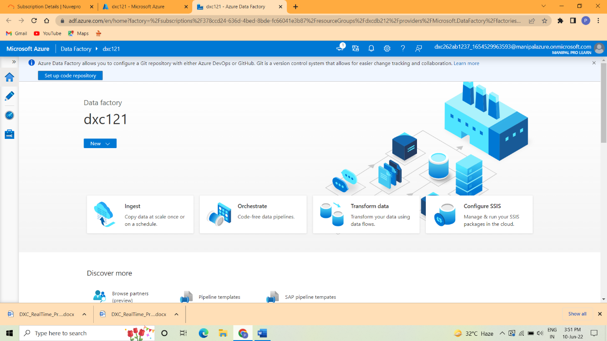

Practical Lab: Create **ADF Pipeline** End to end pipeline with triggers enabled

Step 1: After creating the ADF click on Built in copy task.

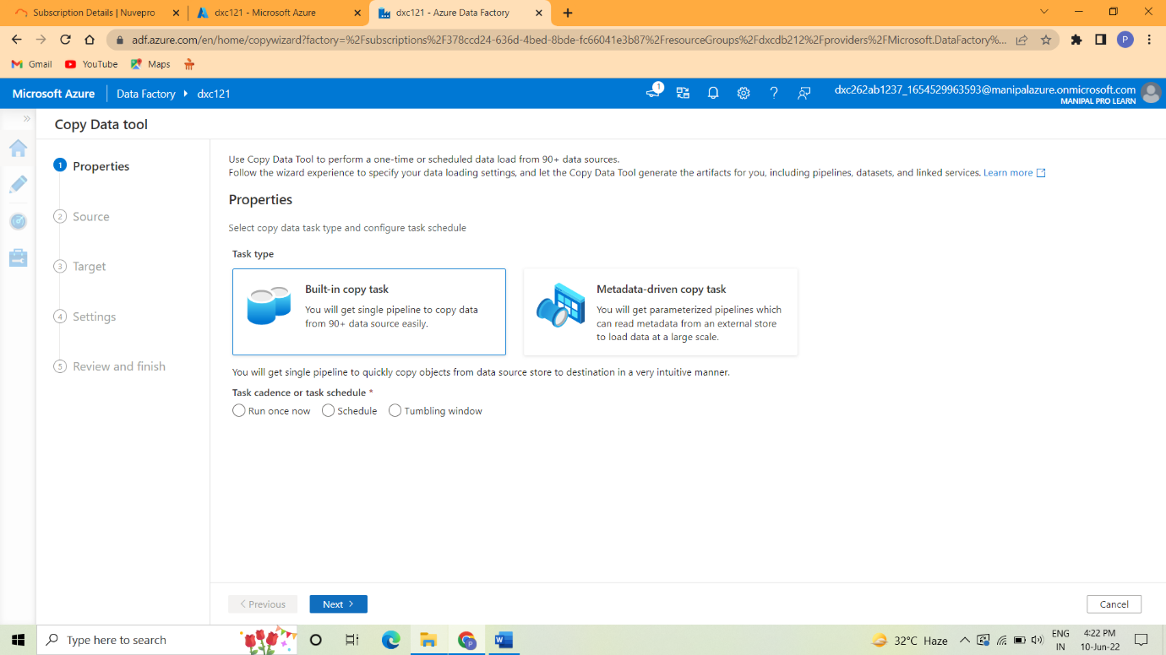

Step 2: Select the Task and then click next.

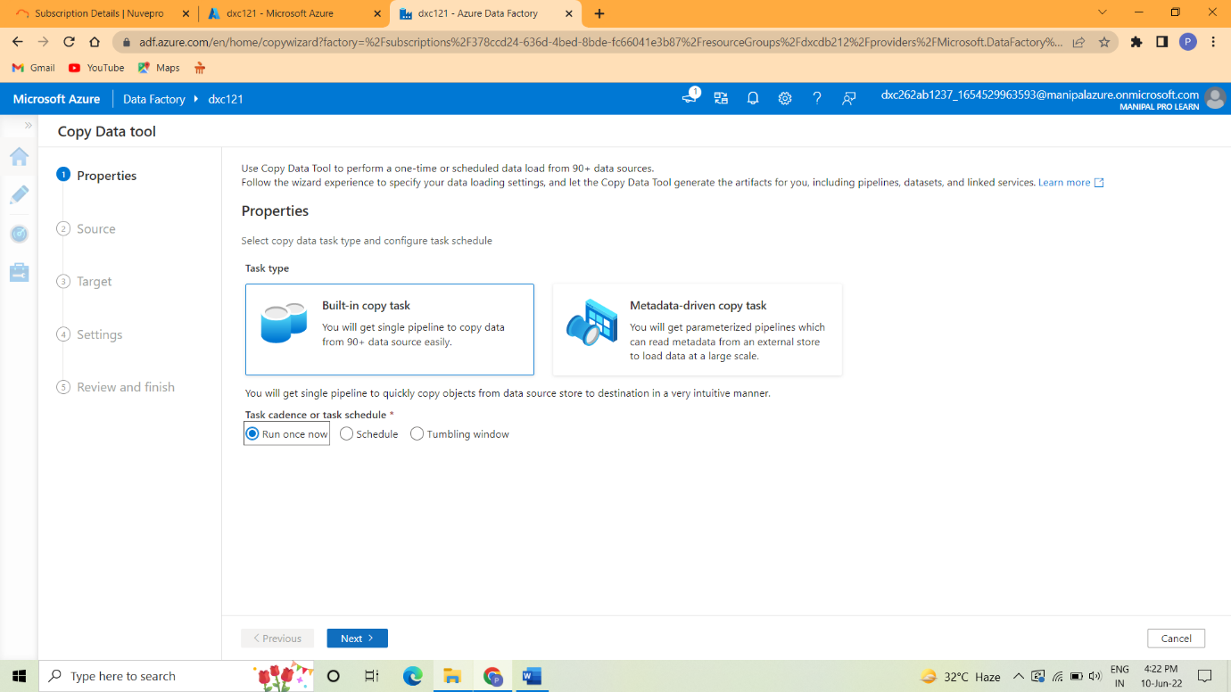

Step 3:In copy data pool process properties->source->Dataset

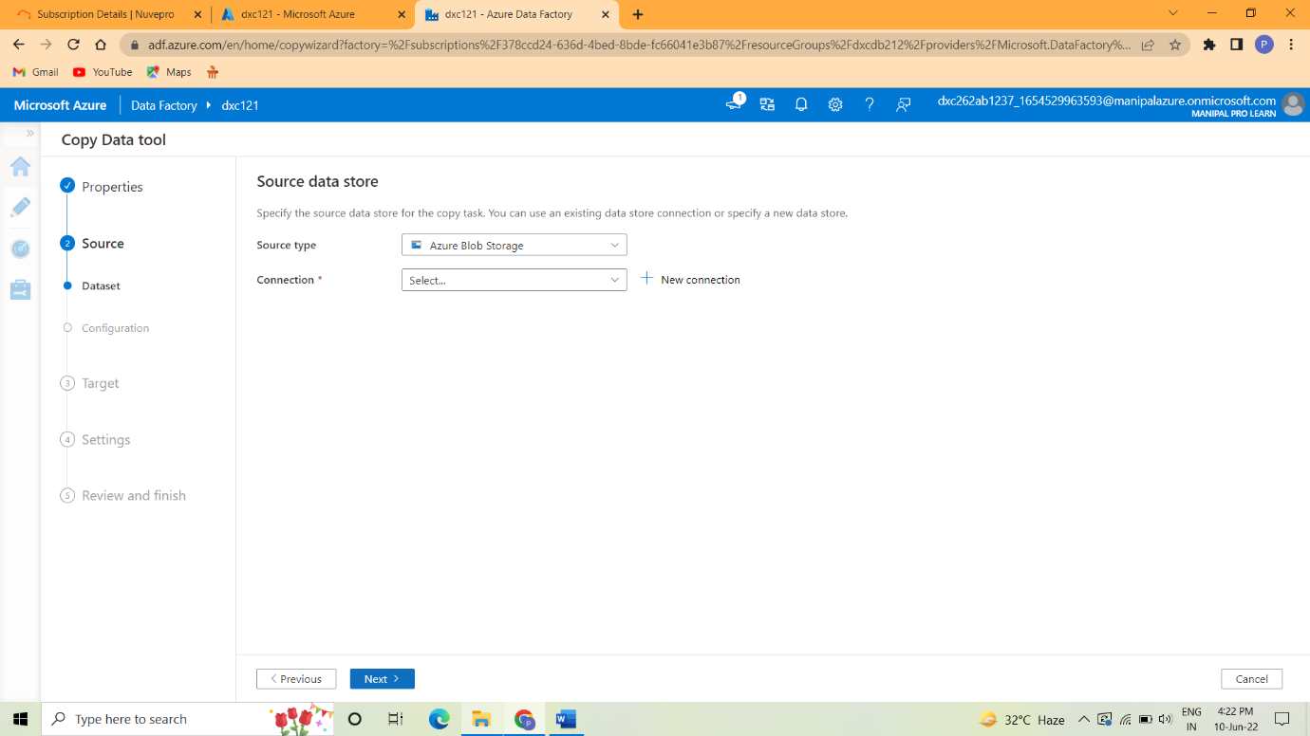

Step 4:In storage account create the source and destination blob.

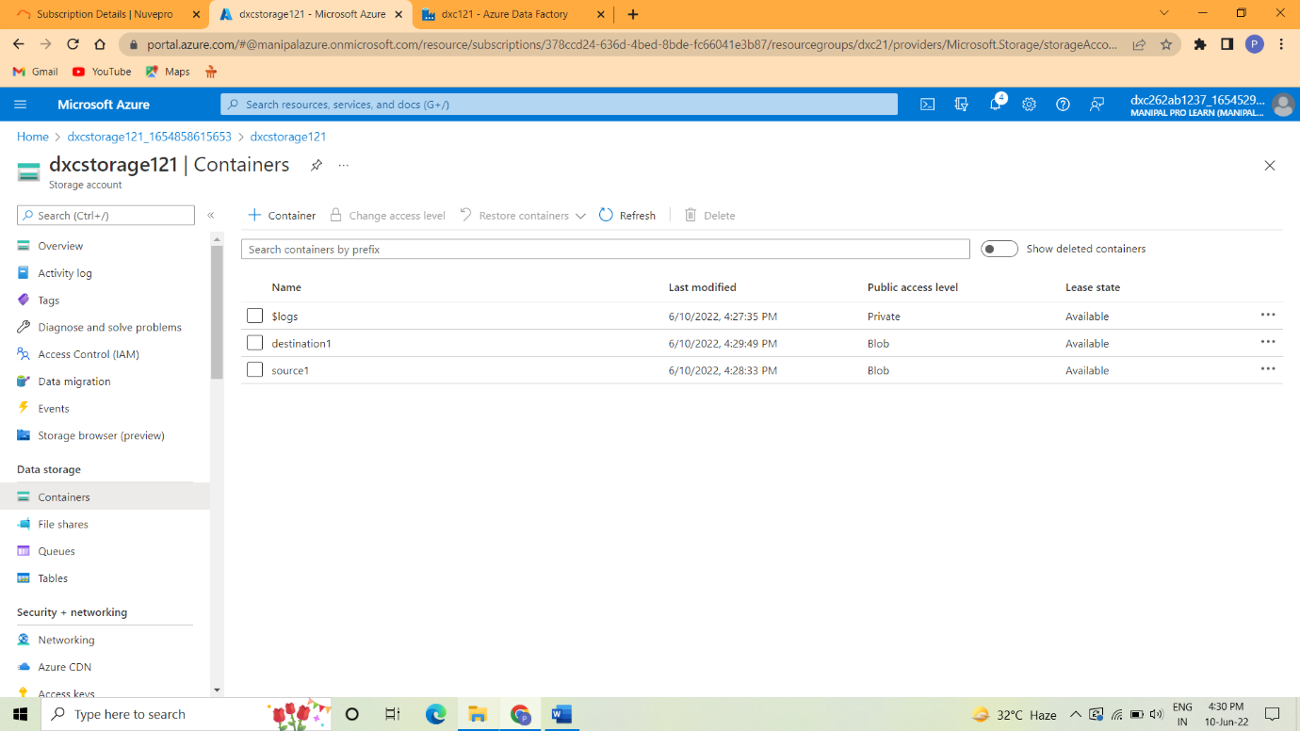

Step 5: In linked service create the connection.

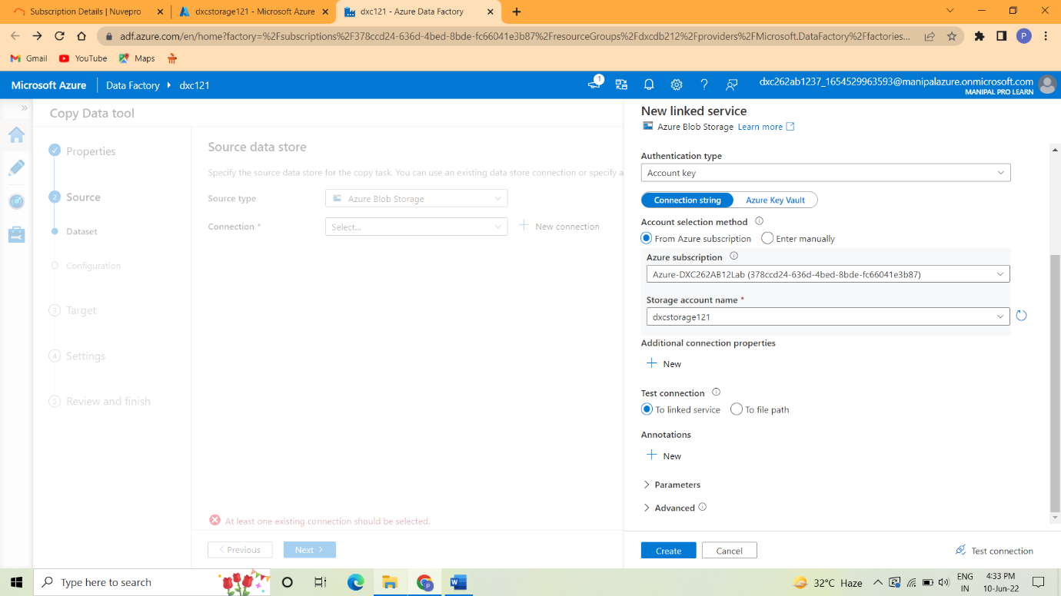

Step 6: In dataset select source and connection type.

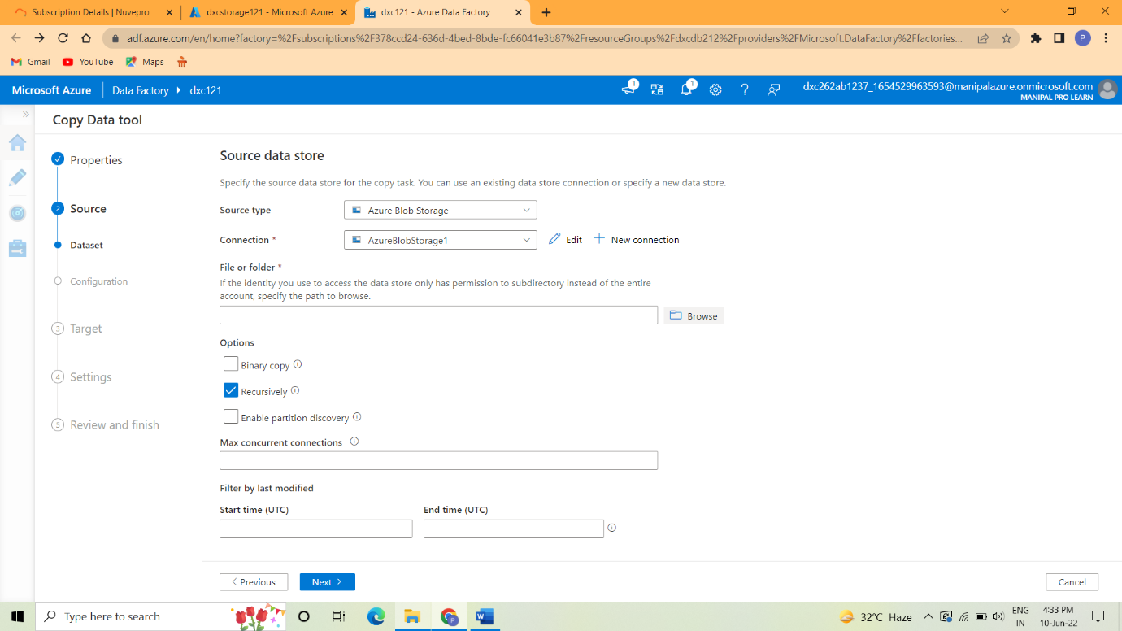



Step 7:In configuration set the file format settings.

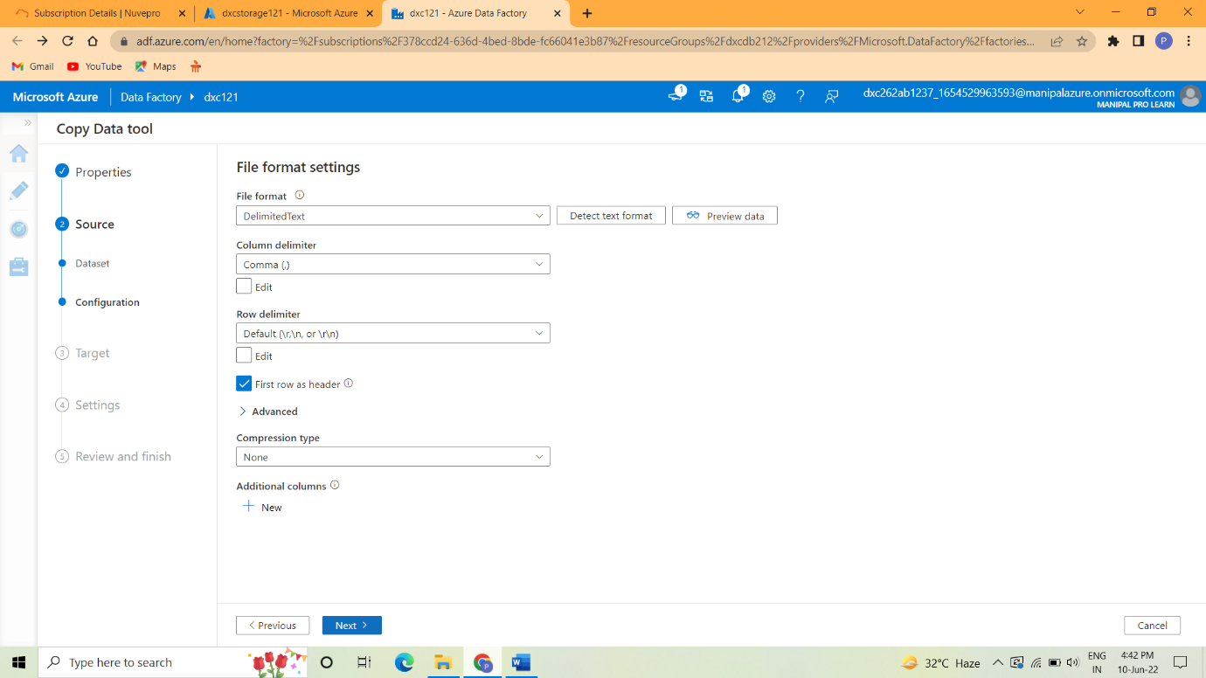

Step 8:Select the Source data store.

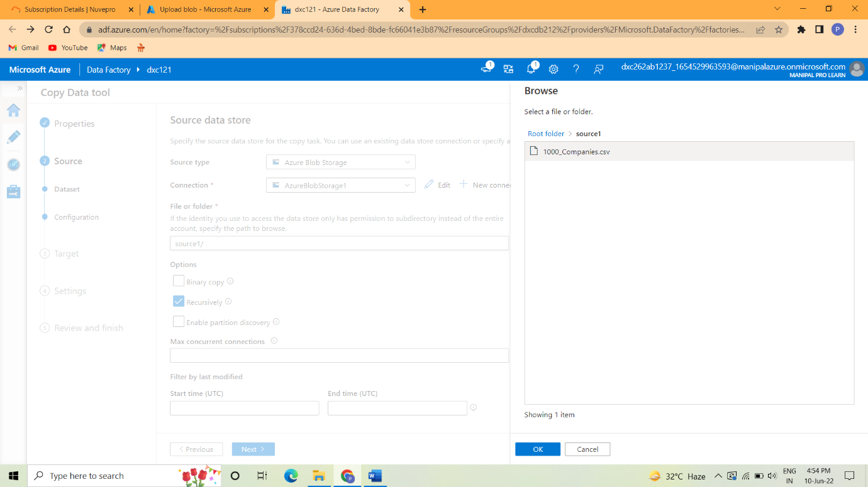

Step 9: Setup the destination data store.

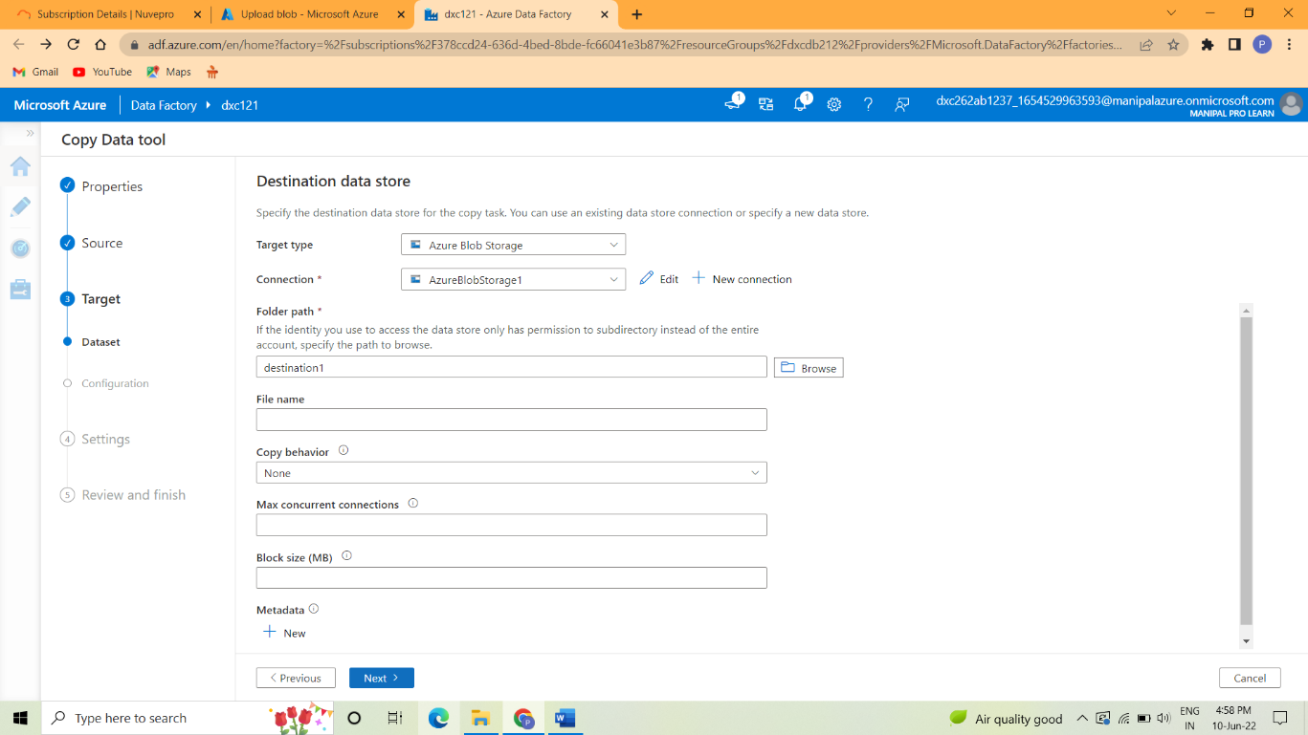

Step 10:Set the file format for destination.

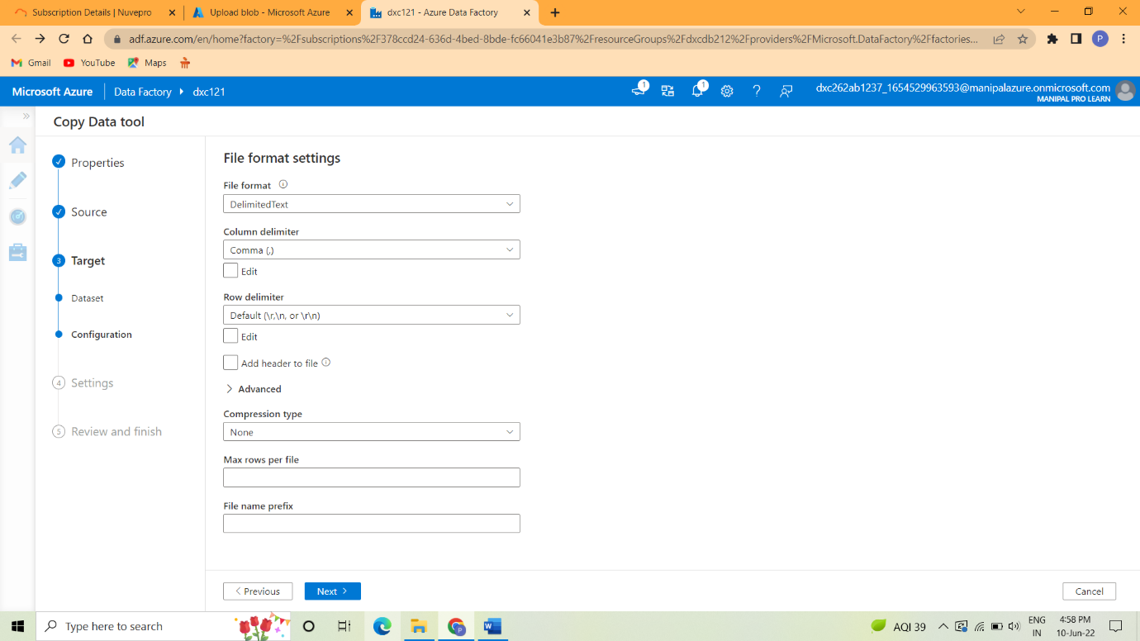

Step 11: The target is send to source to destination.

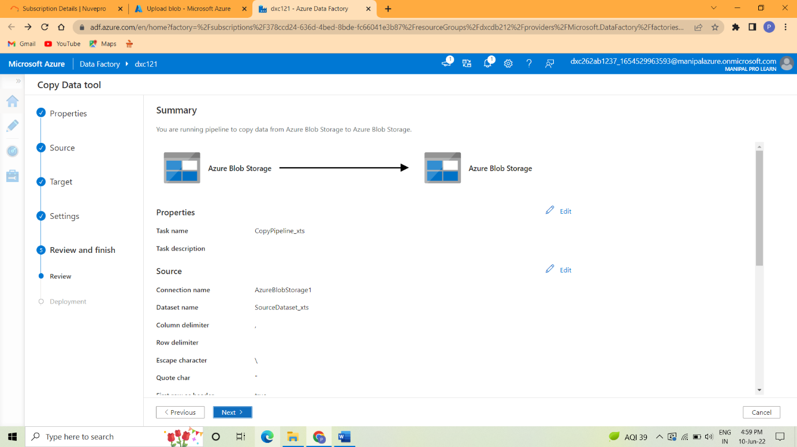

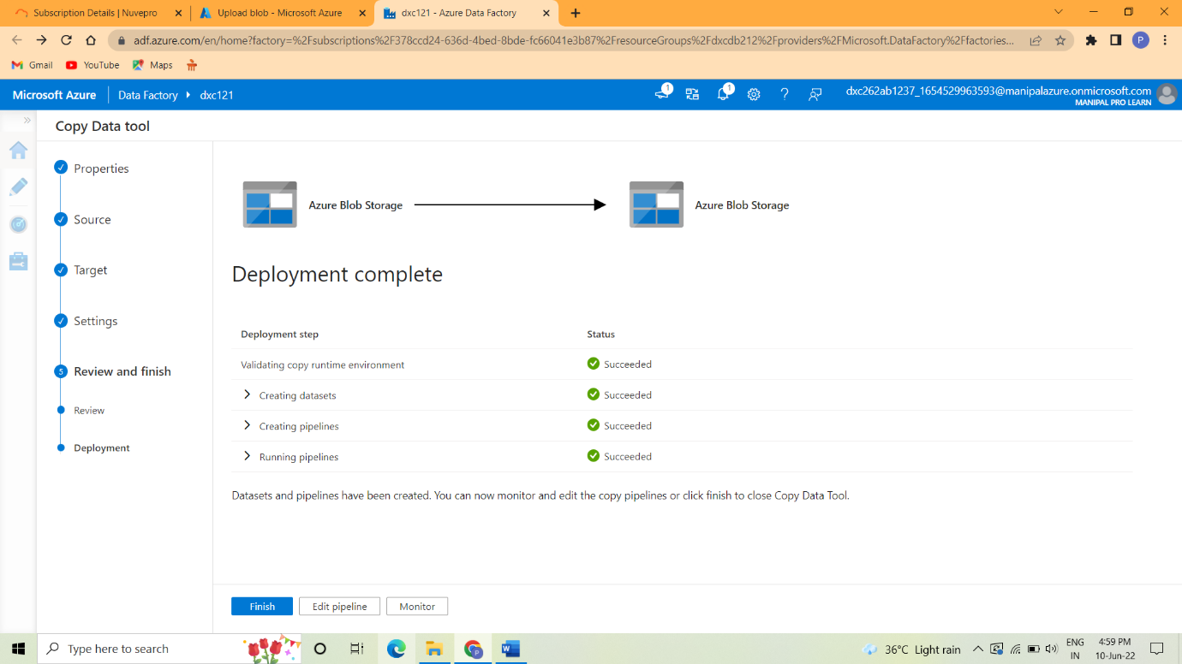

Step 12:After deployment is completed it will go to destination.

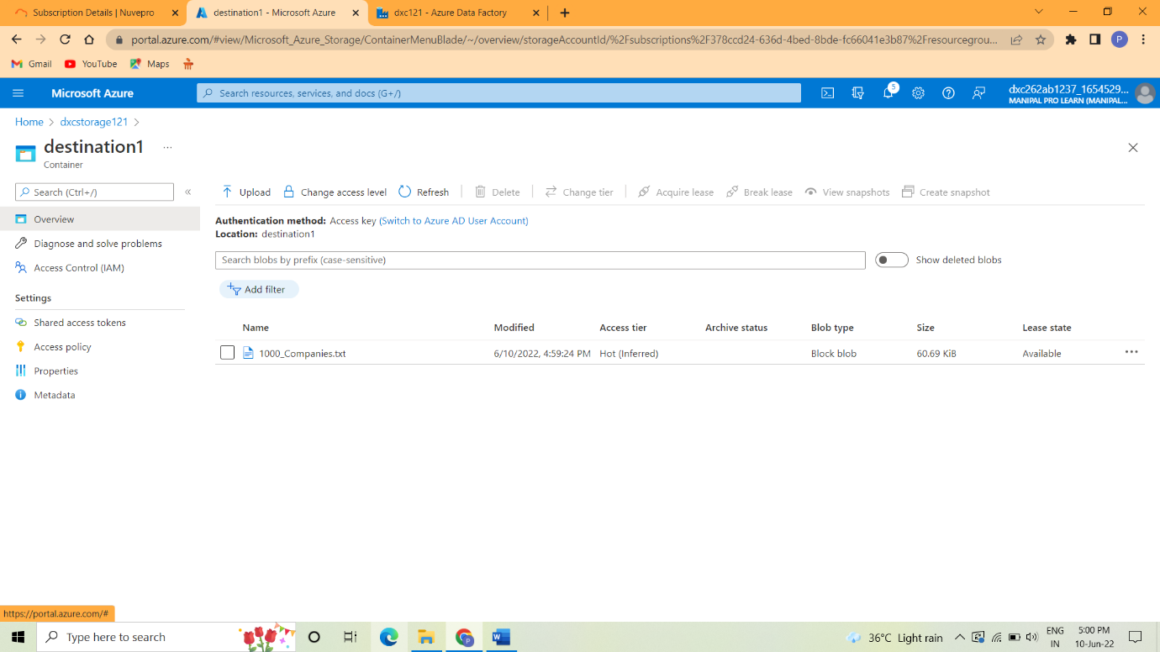

Step 13:In that the pipeline will run.

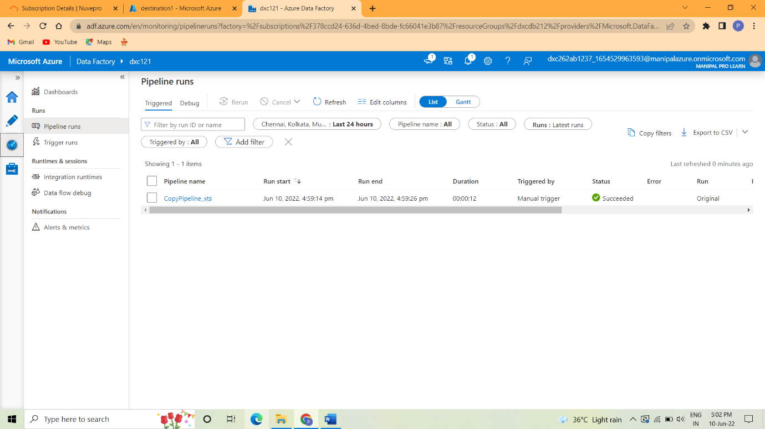

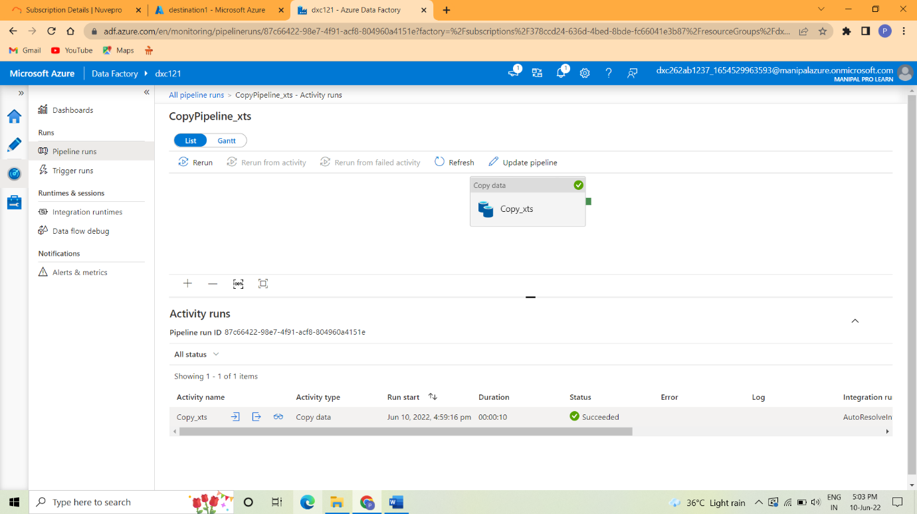

Practical Lab: Create **Azure blob trigger** logic

Step 1:Create the storage account

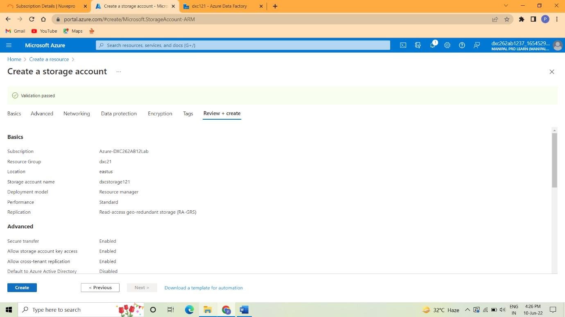

Step 2: After validation is success it go to deployment.

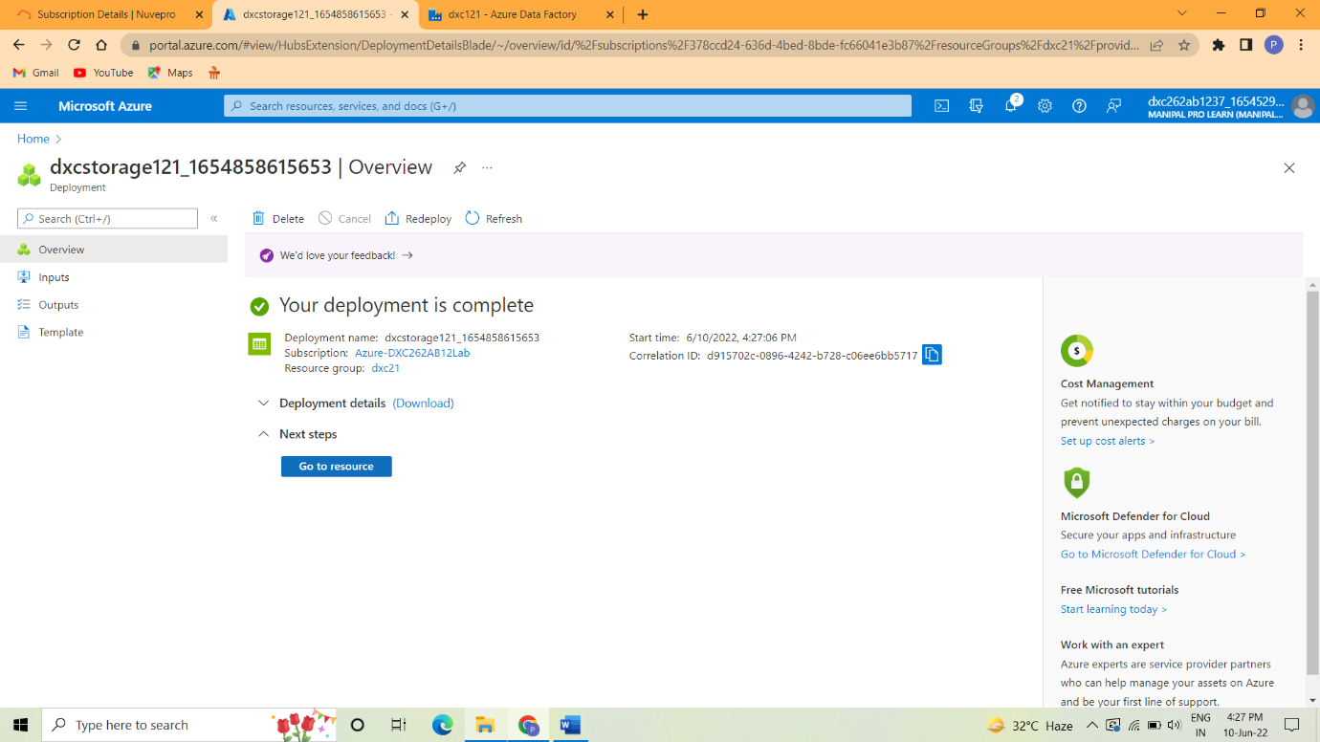

Step 3: After deployment is completed go to resources and then go to containers.

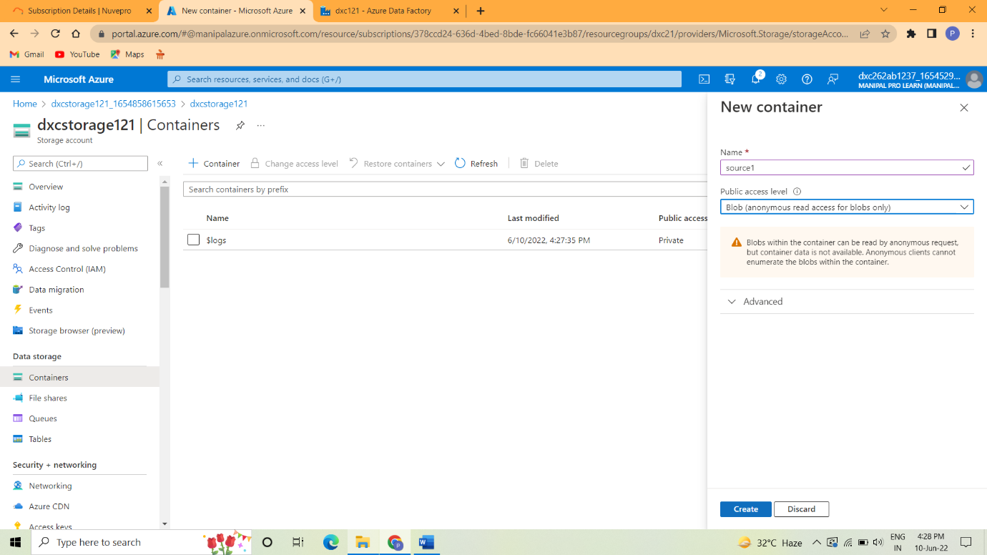

Step 4: In container first create the source blob.

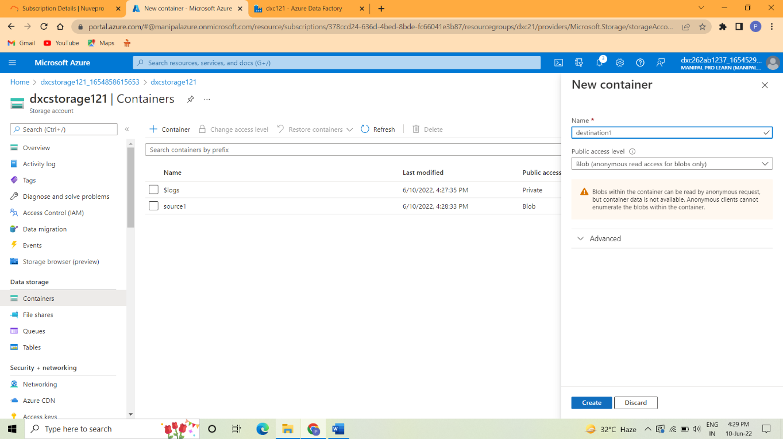

Step 5: After create the source blob then create the destination blob.



Practical Lab: Create Azure **SQL Server and Database**

Step 1: Go to create a resources and then search SQL database.

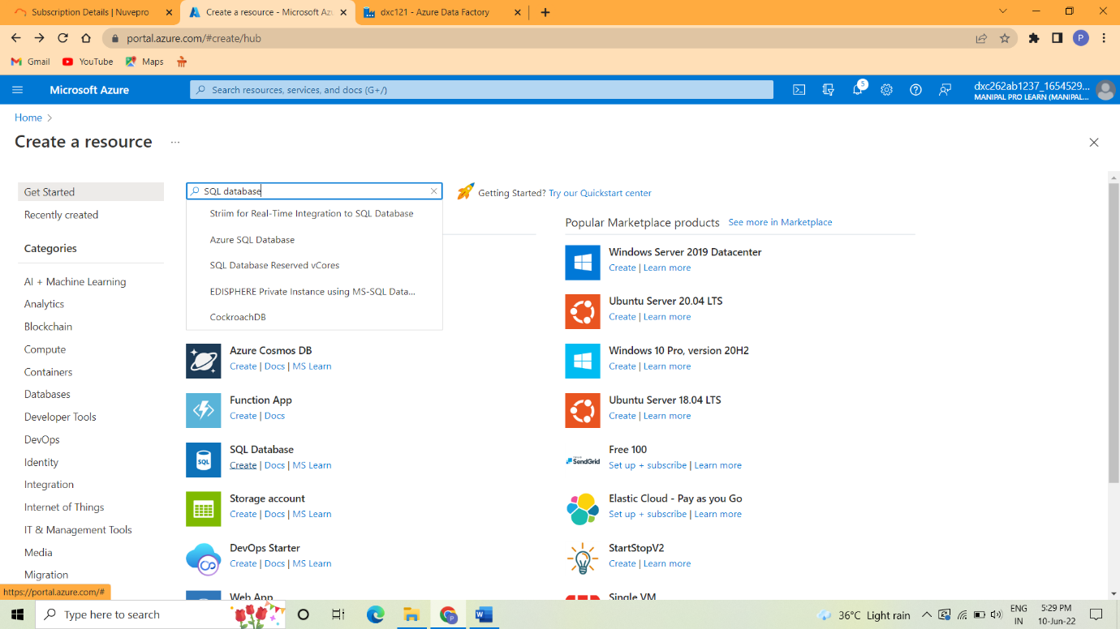

Step 2: Give the server name and location and server admin login and password.

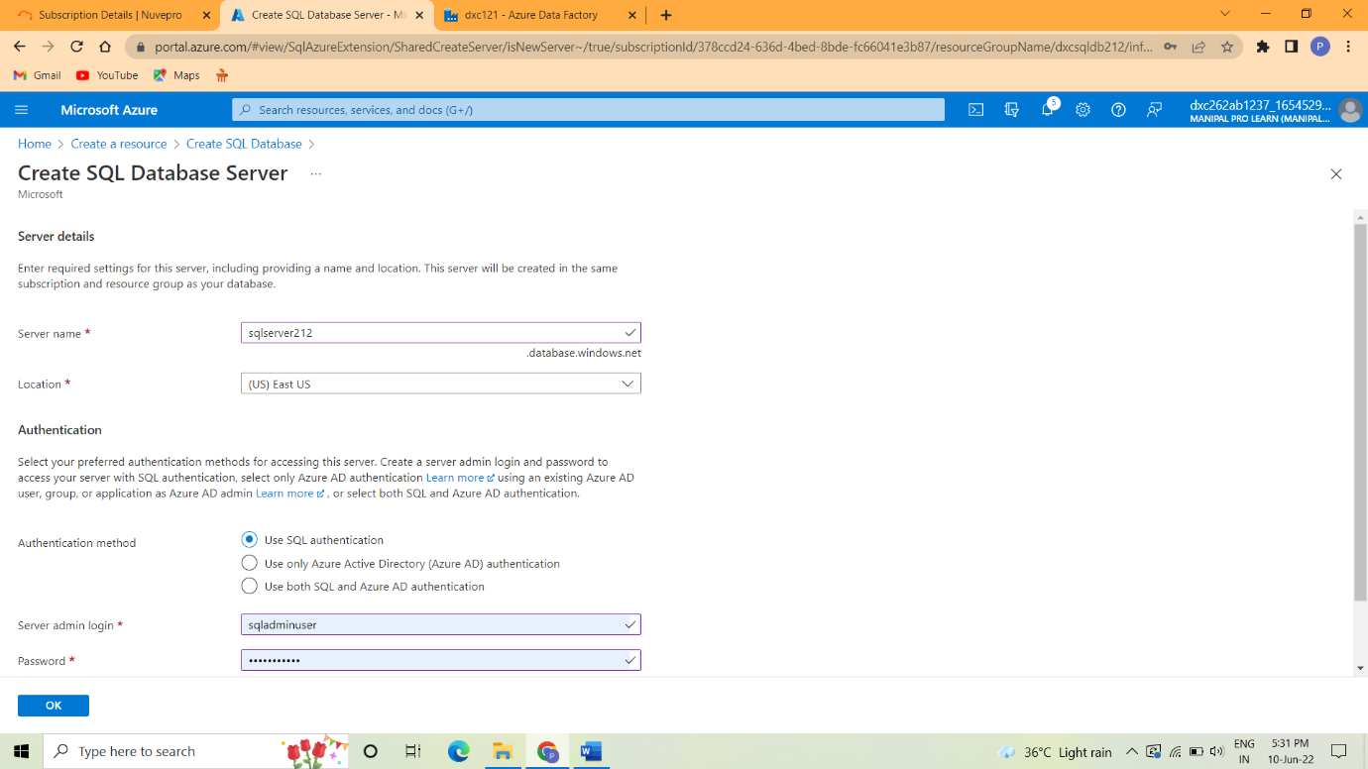

Step 3: Next set the configuration.

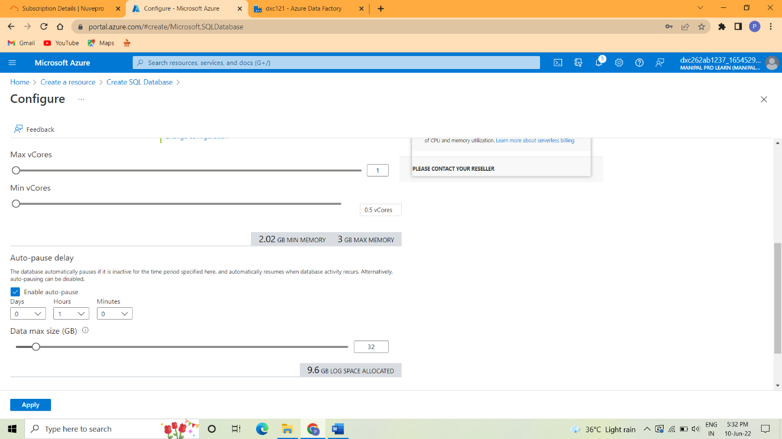

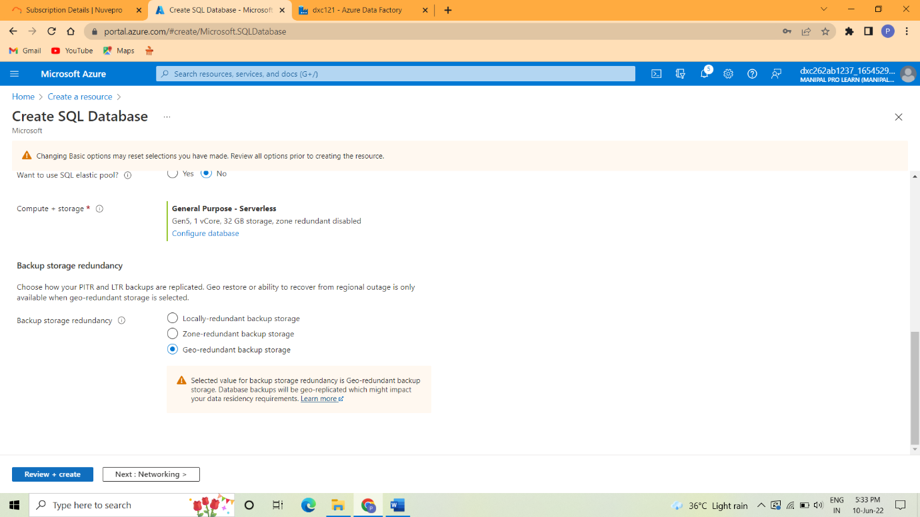

Step 4:Click Review+create to create the SQL database.

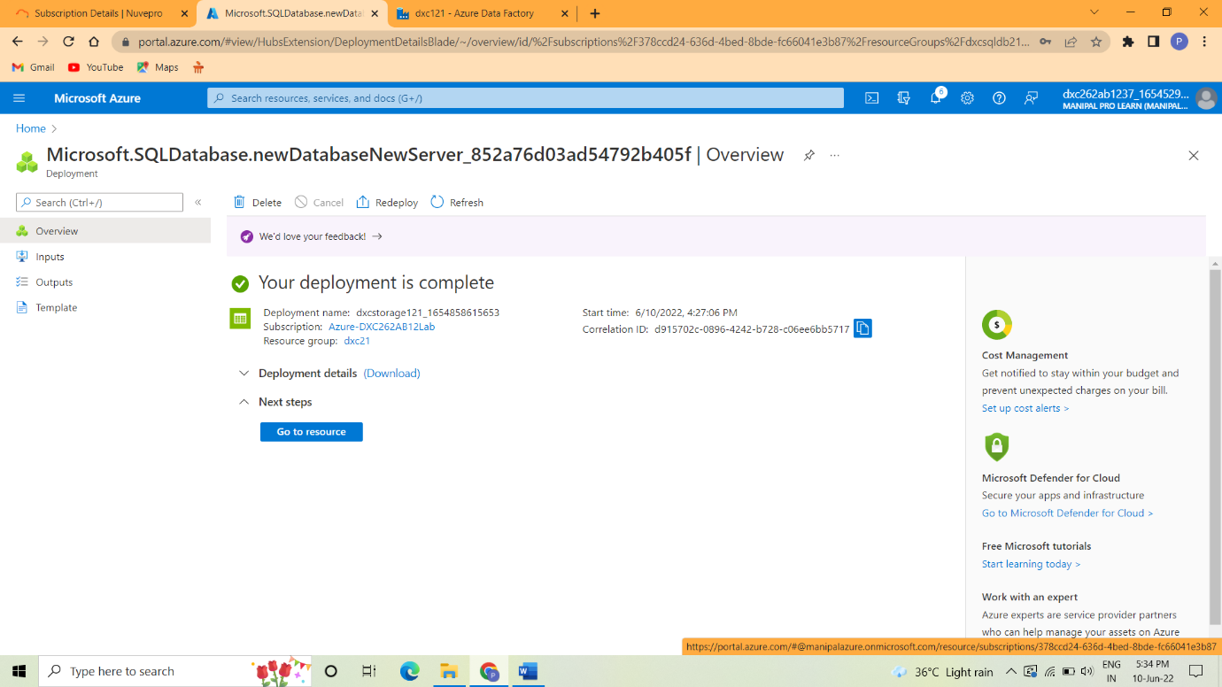

The database server is created successfully after deployment is succeed.

Practical Lab: Add another pipelines for moving data from Staging to **SQL DB**

Step 1: Go to create a resources and then search SQL database.



Step 2: Next set the configuration.



Step 3:Click Review+create to create the SQL database



Step 4:After create the SQL database go to the pipelines



Step 5:The pipeline is added to the SQL server.



**Result:** In this project we are successfully creating the pipeline that will validate and copy the blob data into the SQL database using Azure Data Factory.

**Conclusion:** The blob data is successfully created and validated and then stored into SQL database.

Name: Preethi LNo

Reg No: DXC-262AB-1237

**Project2 Name: AP Morgan Data Platform**

Date:10.06.2022

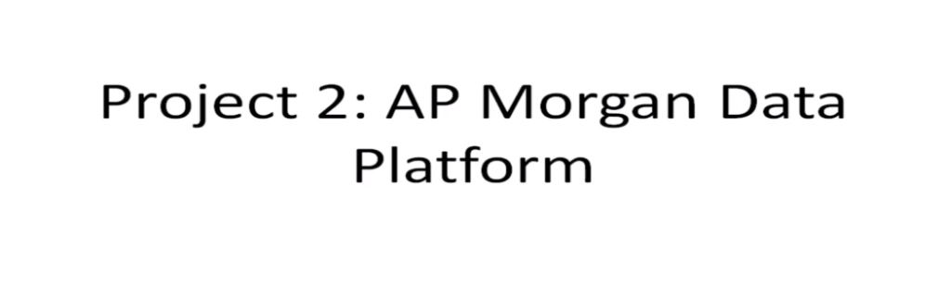

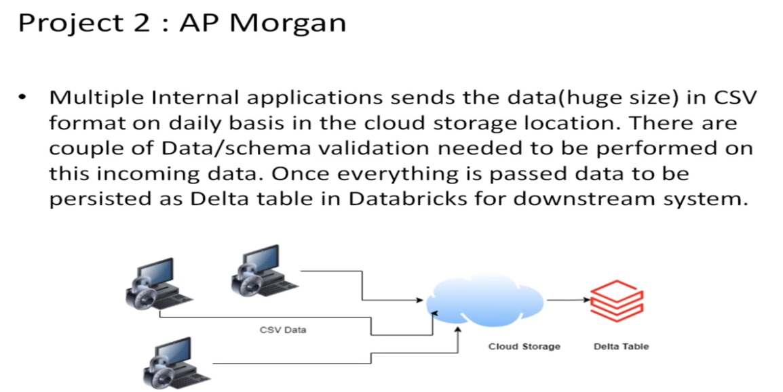

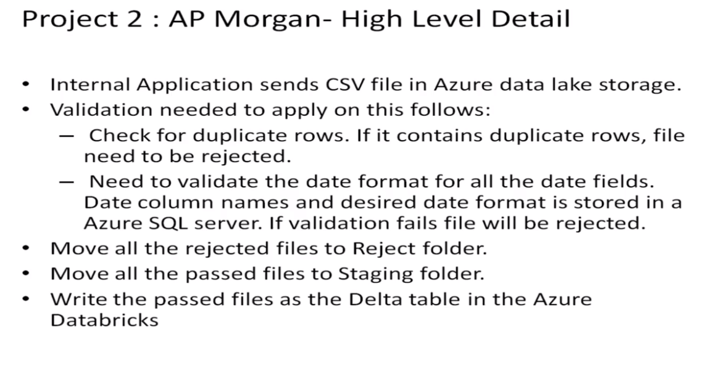

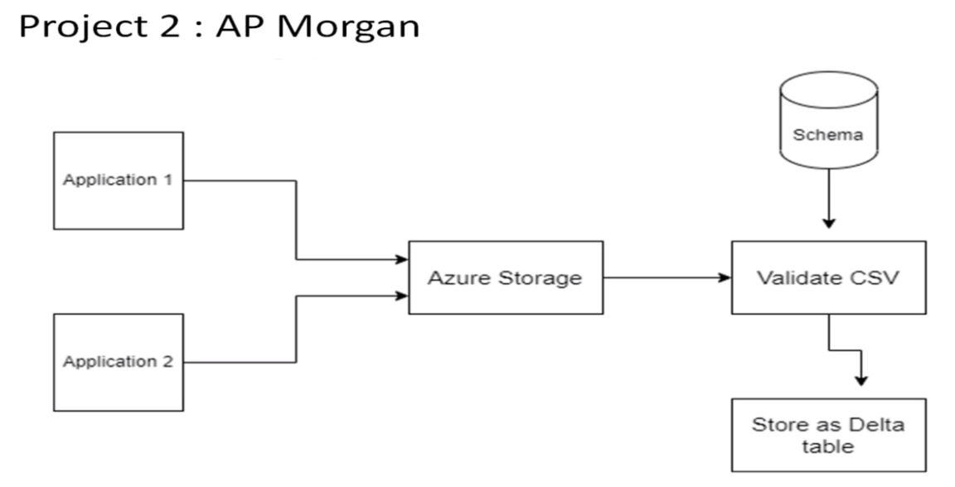

Practical Lab: Create a **Databricks**

Step 1: Go to the create resources and then search Databricks and it will be opened.

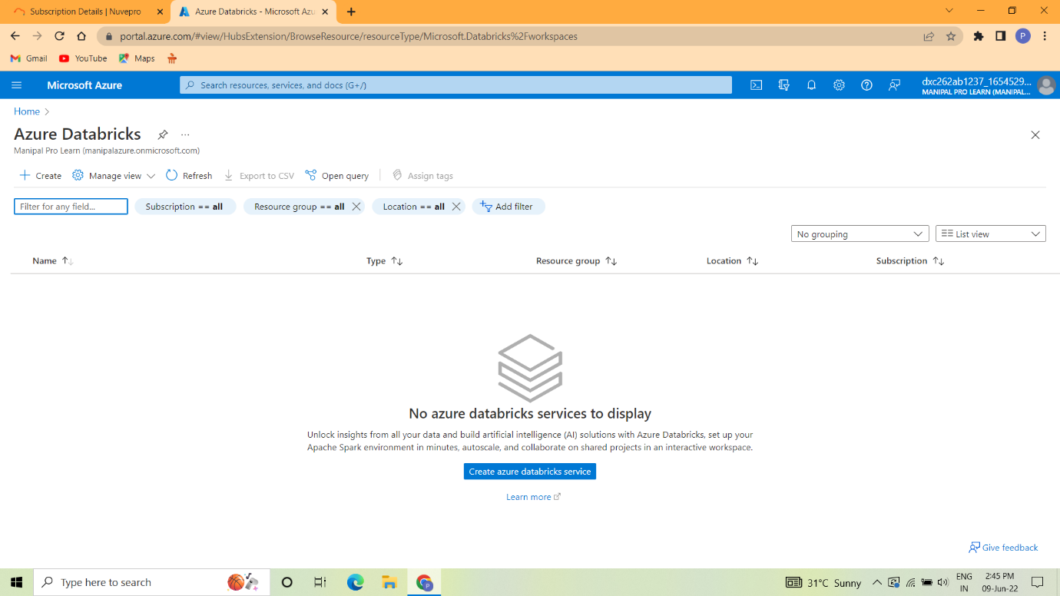

Step 2: Give the subscription and instance details and then click Review+create.

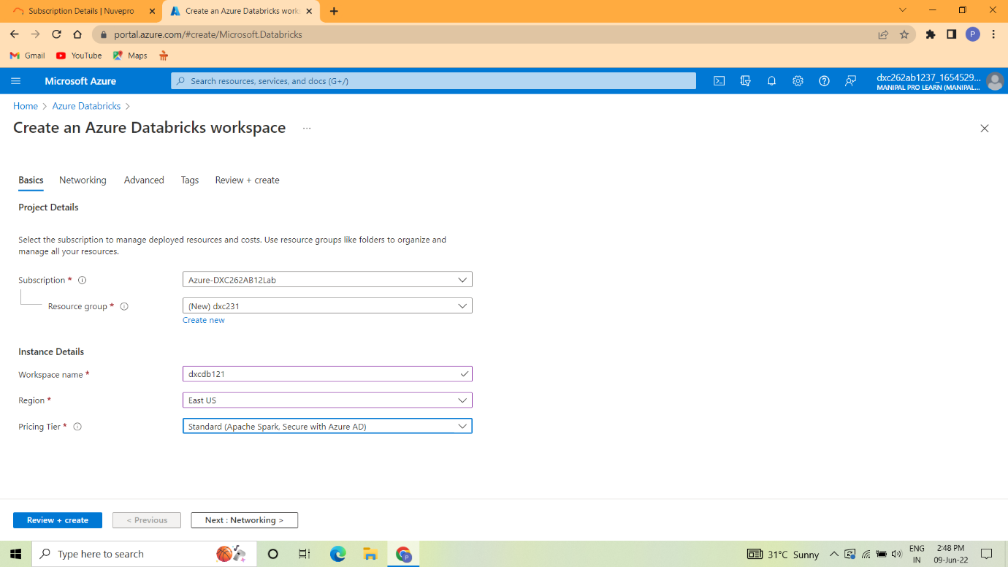

Step 3: After validation is success click the create button.

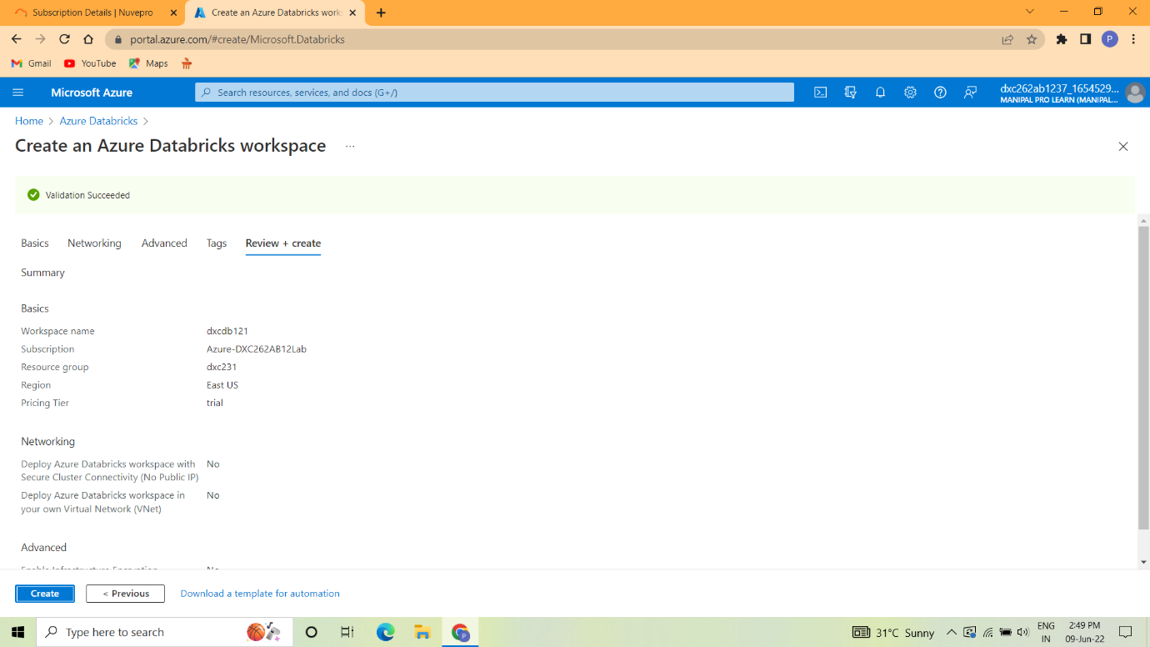

Step 4: The deployment is in progress after it completed click on go to resource button.

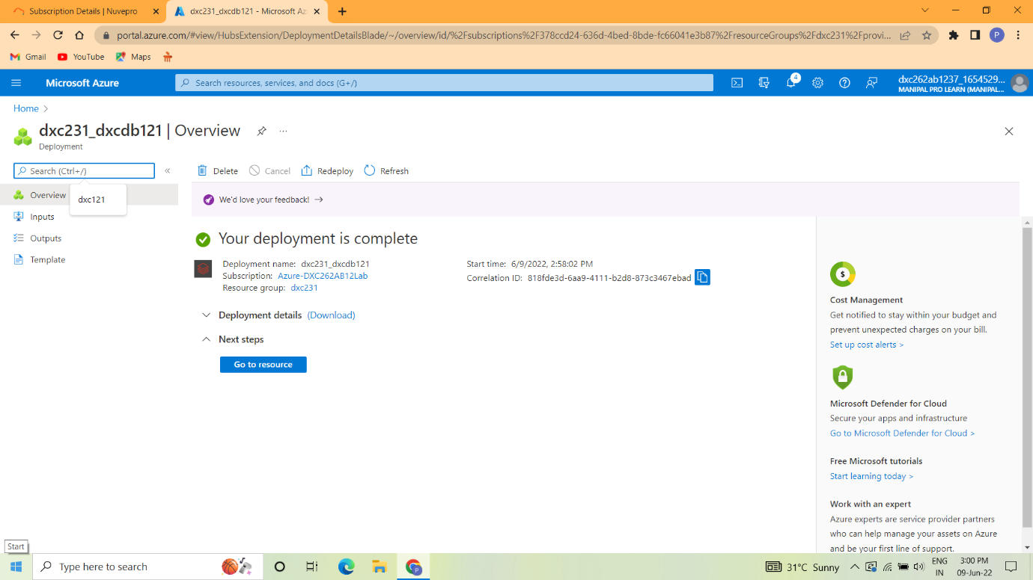

Finally Data Bricks is created successfully.

Practical Lab: Create **Cluster in Azure Databricks**

Step 1: Open the Azure Databricks and then click on the cluster button.

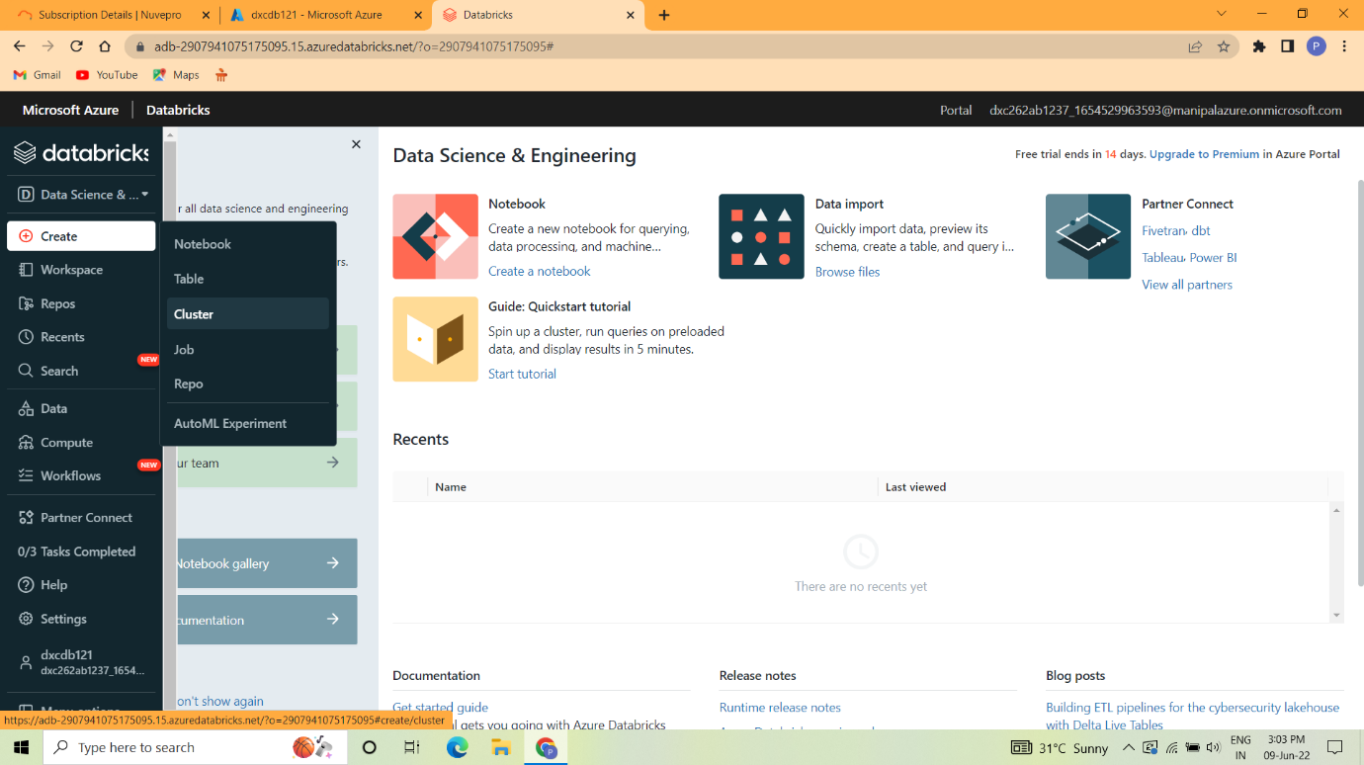

Step 2: The cluster is created after give the name of the cluster.

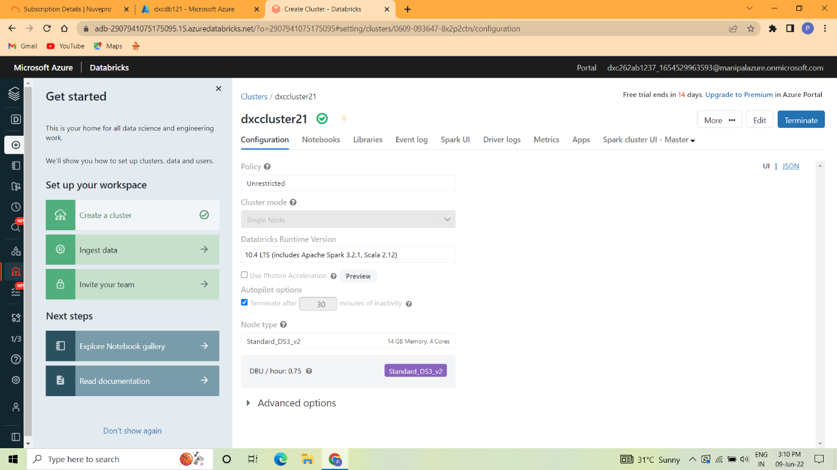

Step 3: In create cluster the new cluster will be opened.

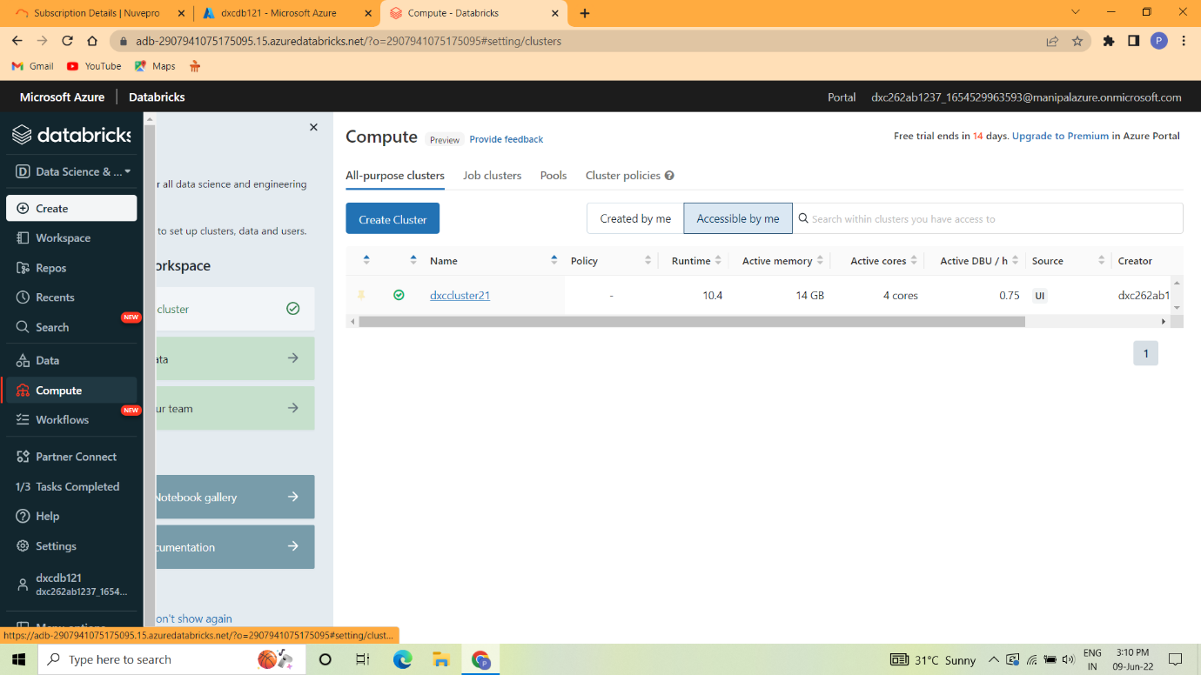

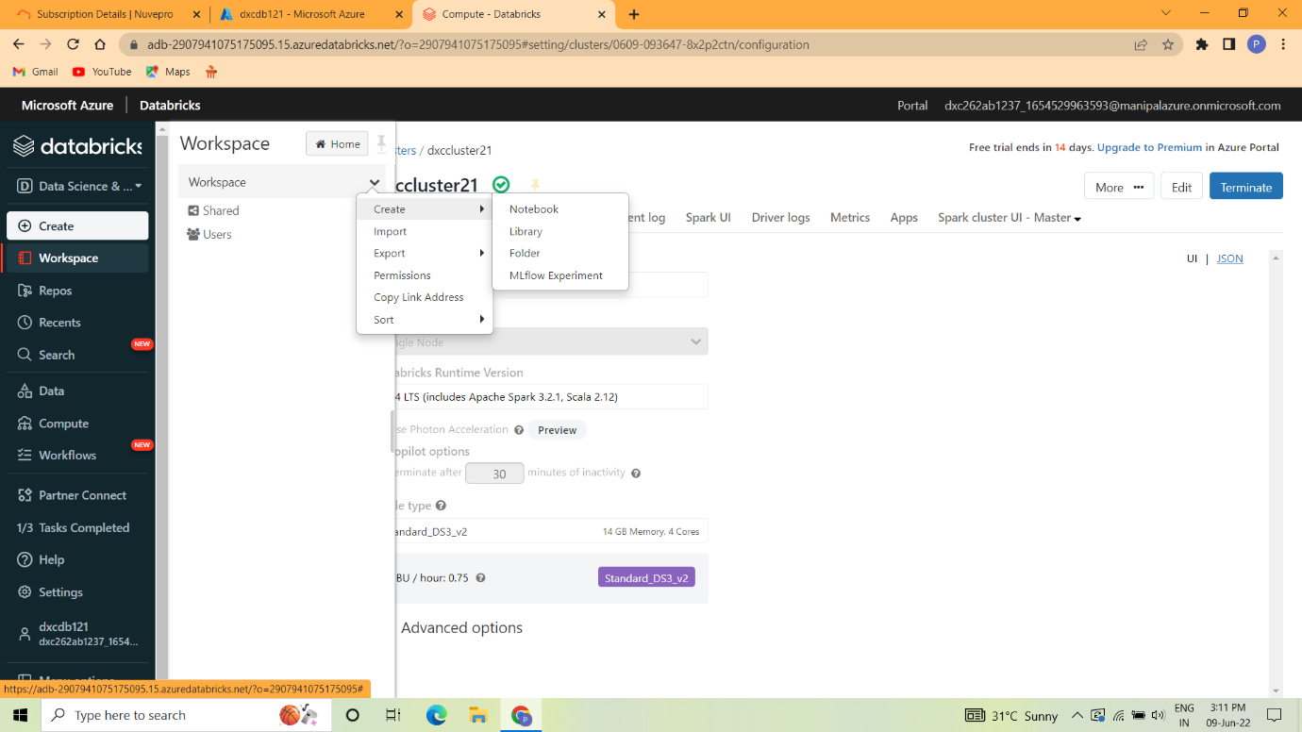

Practical Lab: **Add notebook in Databricks** and Implement the Business Logic

Step 1: Go to the data bricks and then click Create-> Workspace-> create-> Notebook

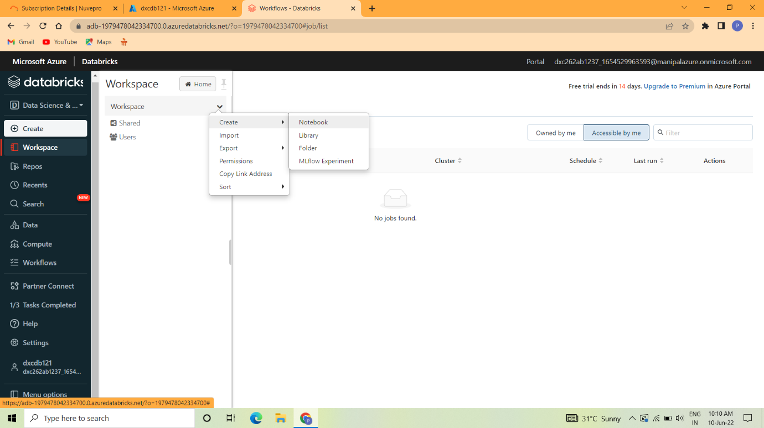

Step 2:The notebook is open and then give the name.

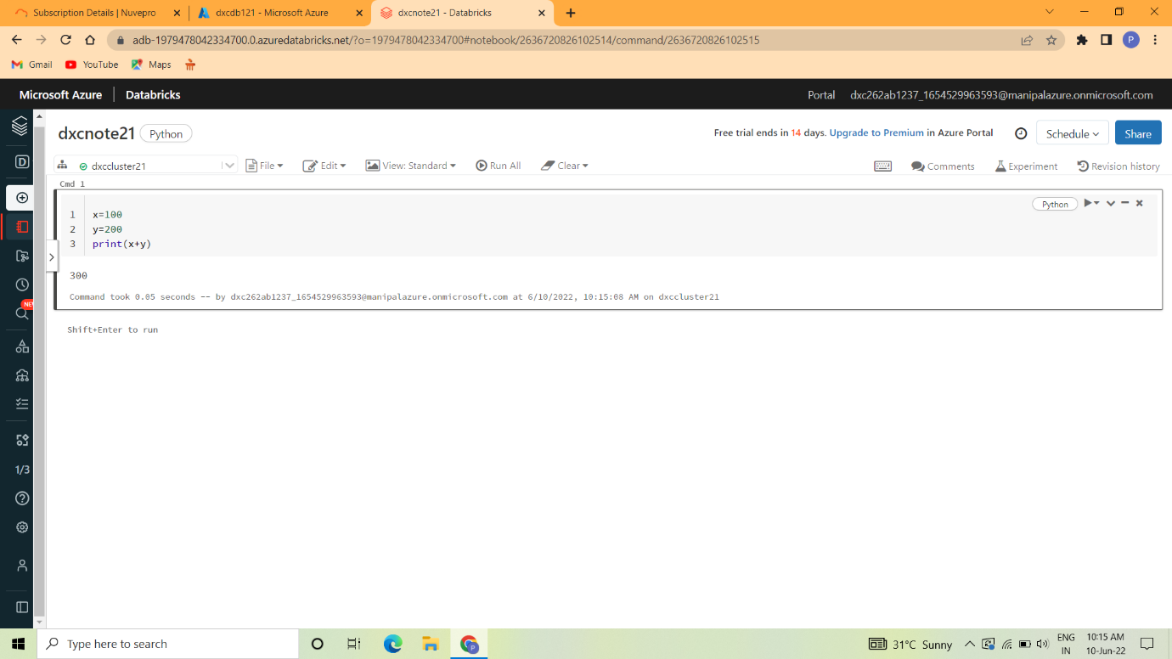

Step 3:Selcet notebook and then confirm.

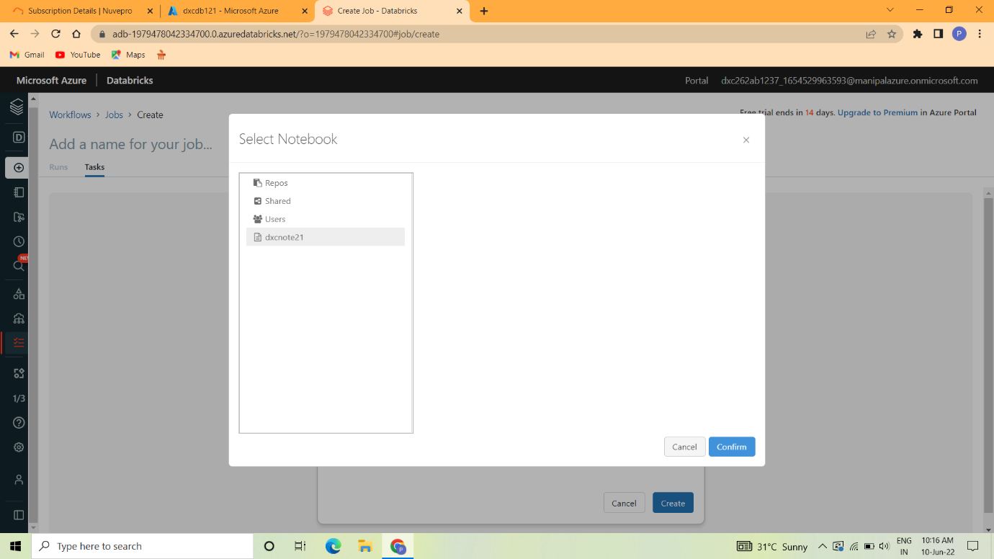

Step 4:Select type and then create.

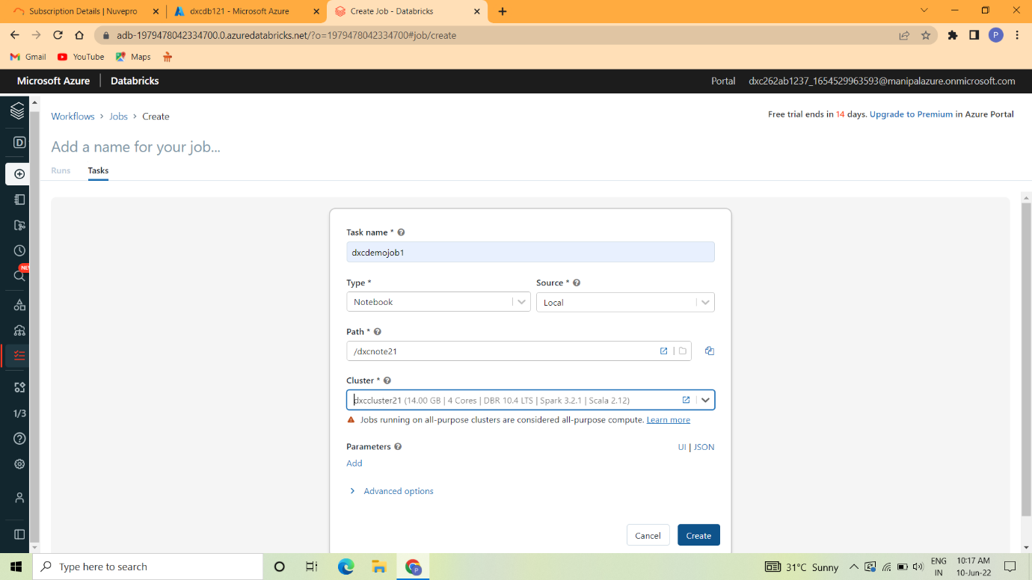

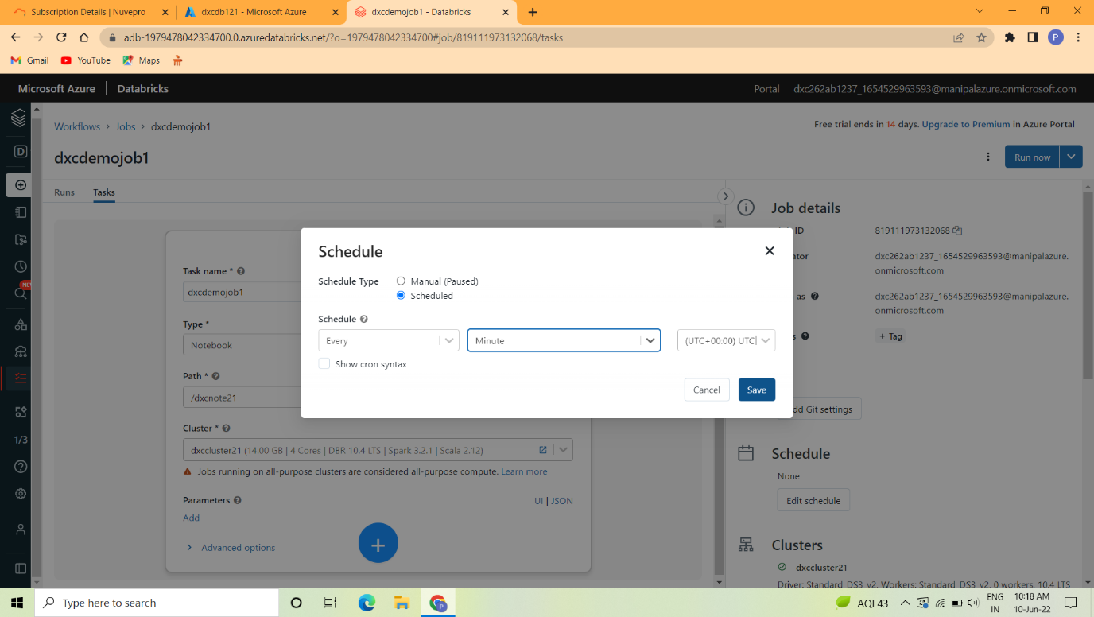

Step 5:Select schedule and then click on email alerts.

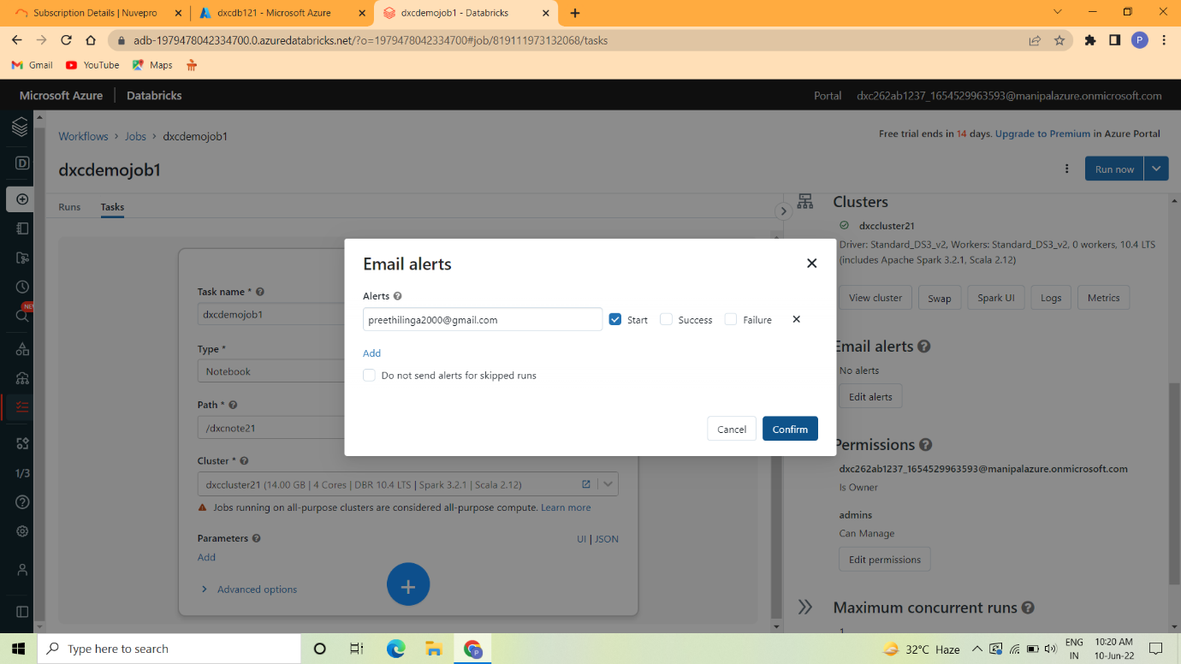

Step 6:Download the Microsoft Power BI

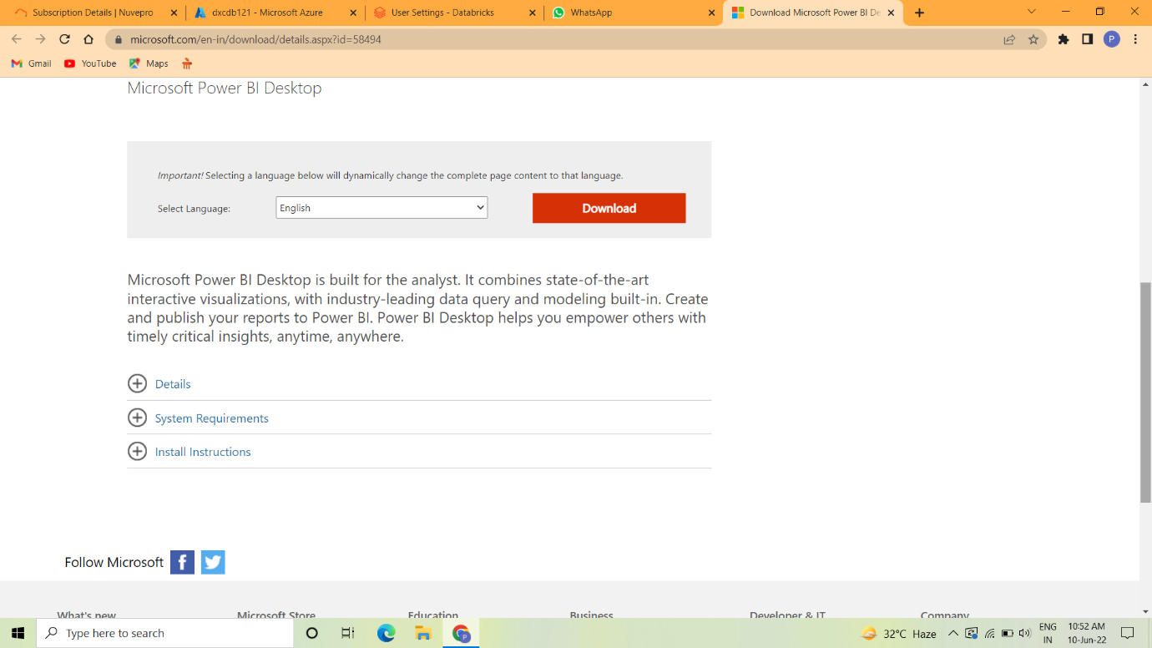

Step 7 : Open the Power BI.

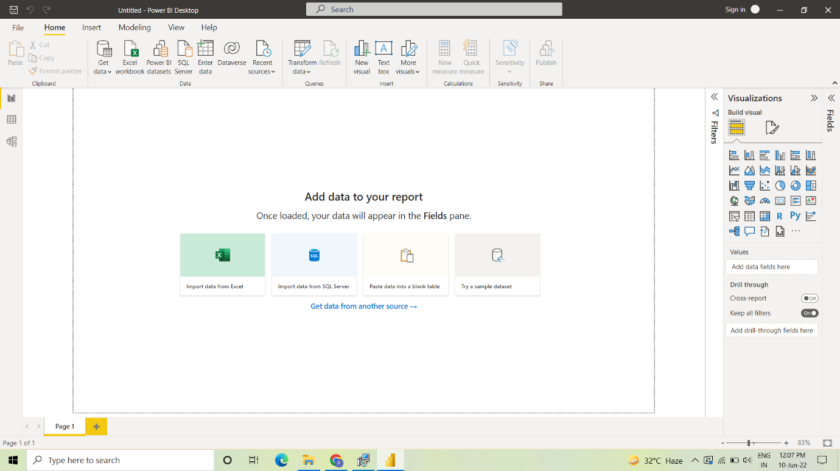

Step 8: Select the fill to run.

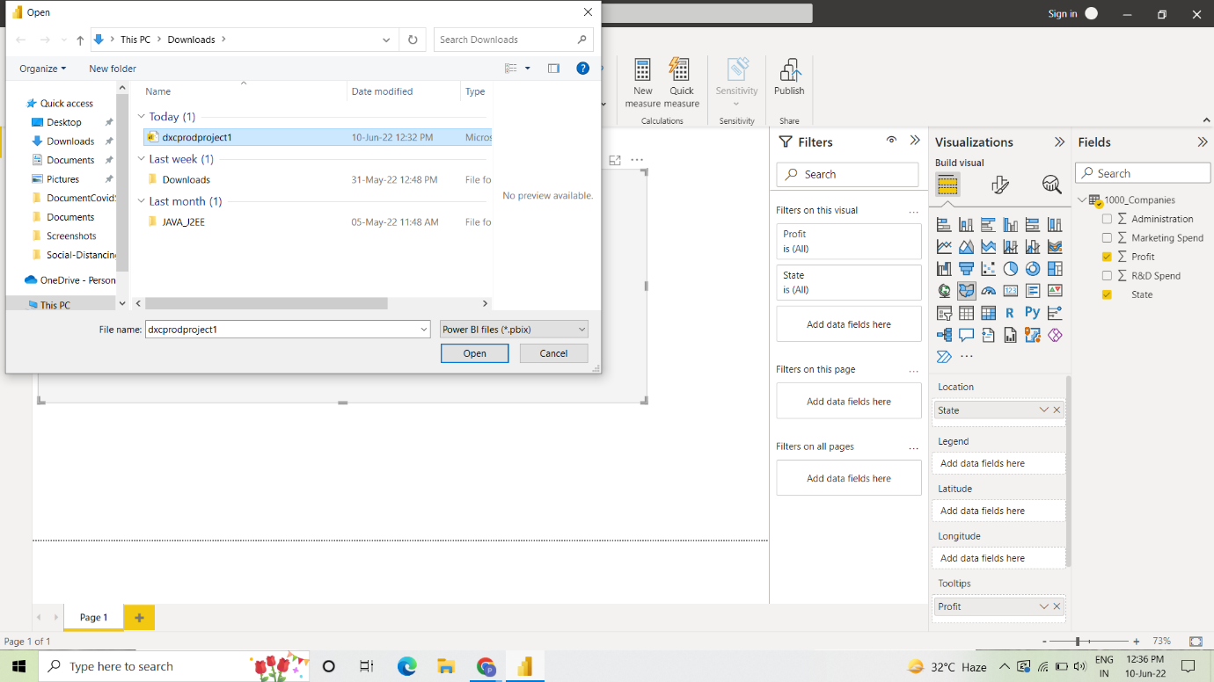

Step 9:The power BI is run and give the result.

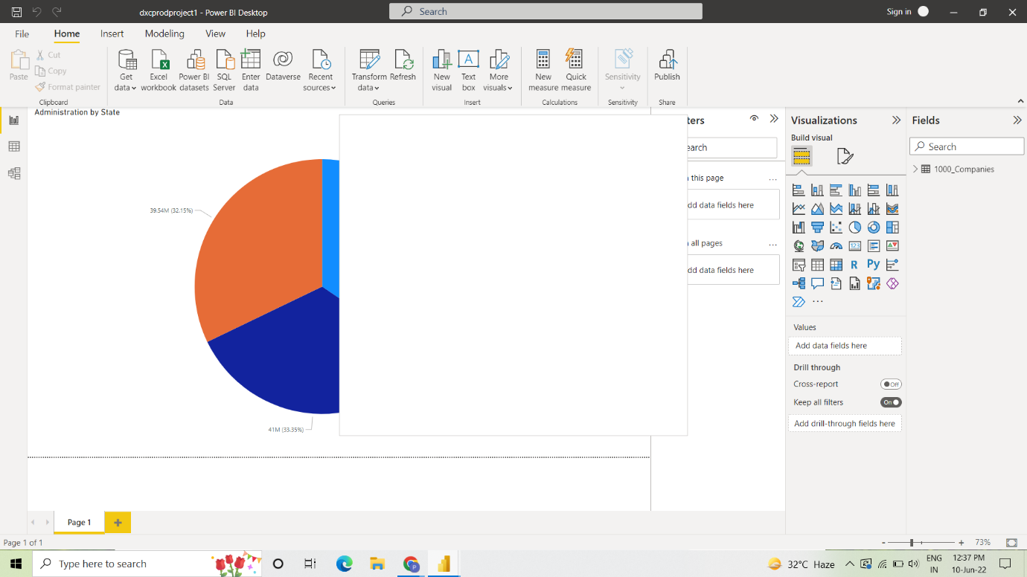

Practical Lab: **Azure Data Factory** For AP Morgan

Step 1: Go to Azure account and go to create a resource and then search on Data Factory.



Step 2: Click the Create button.



Step 3: In the Basic tag fill the subscription and instance details. And then click next button.



Step 4 : Go to Git configuration and then select configure Git



Step 5: Click Review+create button

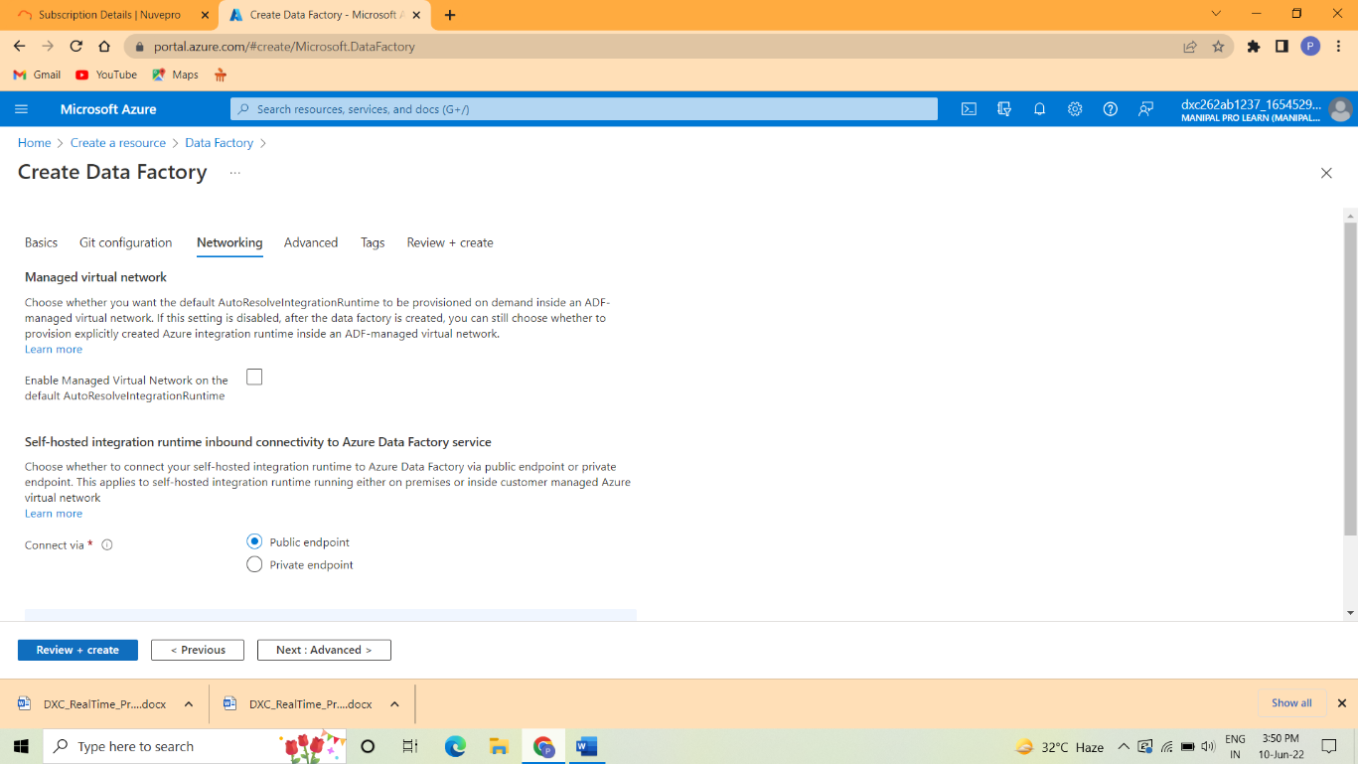

Step 6:After deployment is completed go to the resources.



Step 7:Data Factory is created successfully.



Practical Lab: **Create Azure Databricks** Linked Service in ADF

Step 1: After create the Azure Data Factory click the manage button.

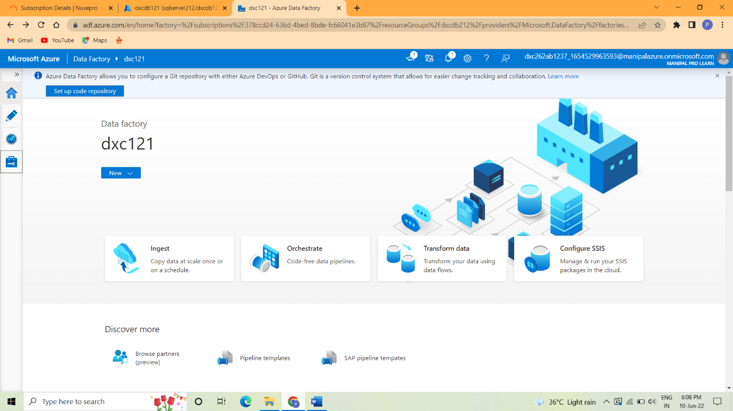

Step 2: And then click New->Linked servies->

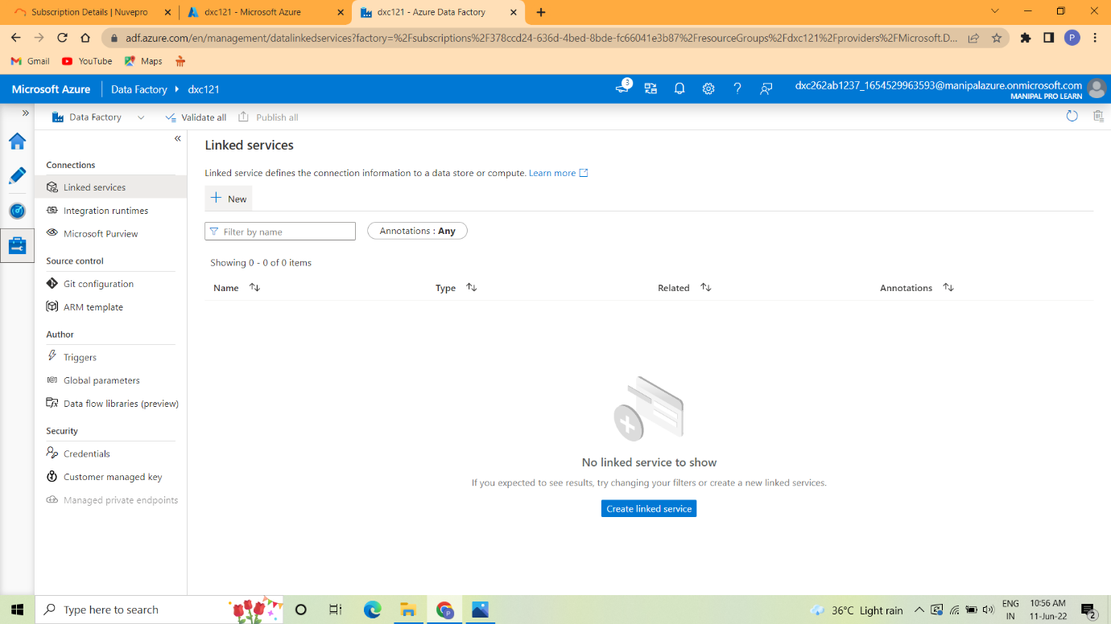

Step 3: In New Linked Services go to compute and then select Data bricks and the click ok.

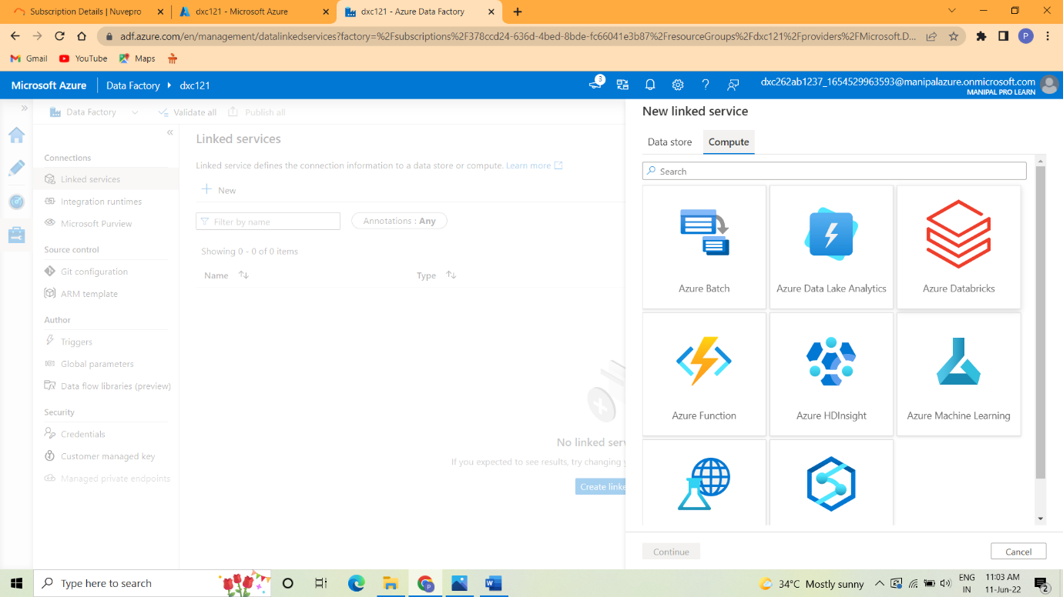

Step 4: Fill the account name and subscription.

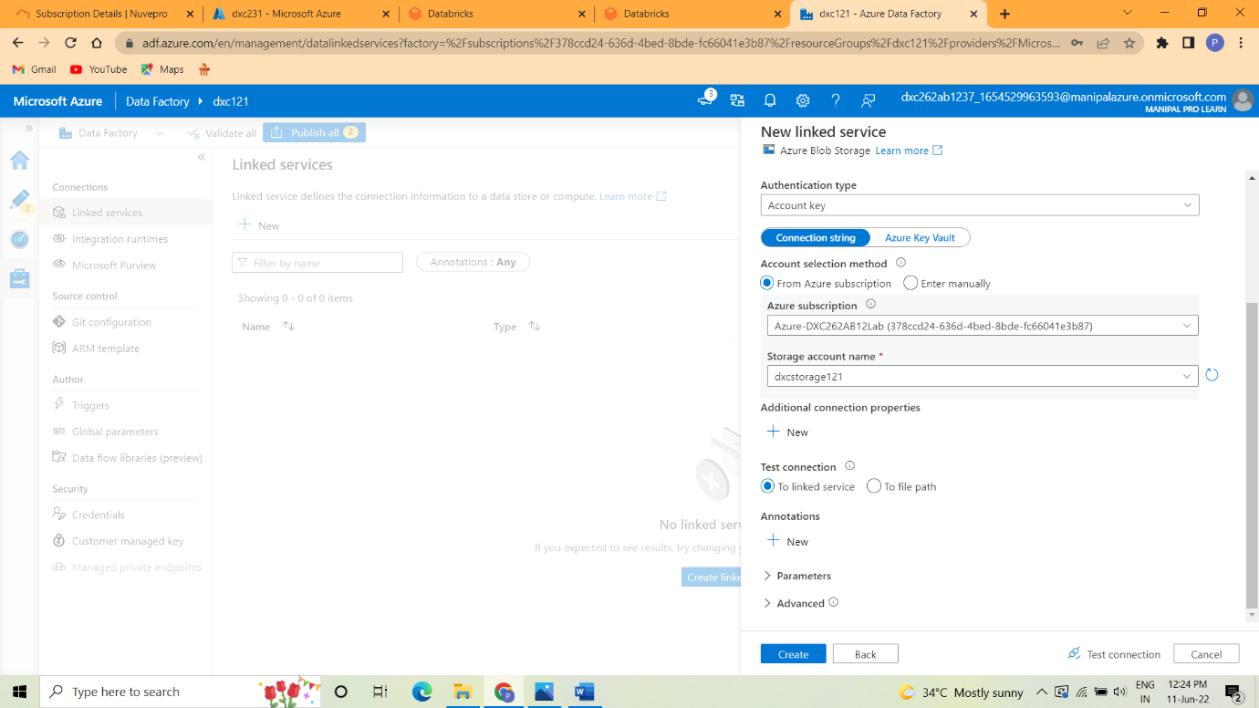

Step 5:Select cluster nide and type.

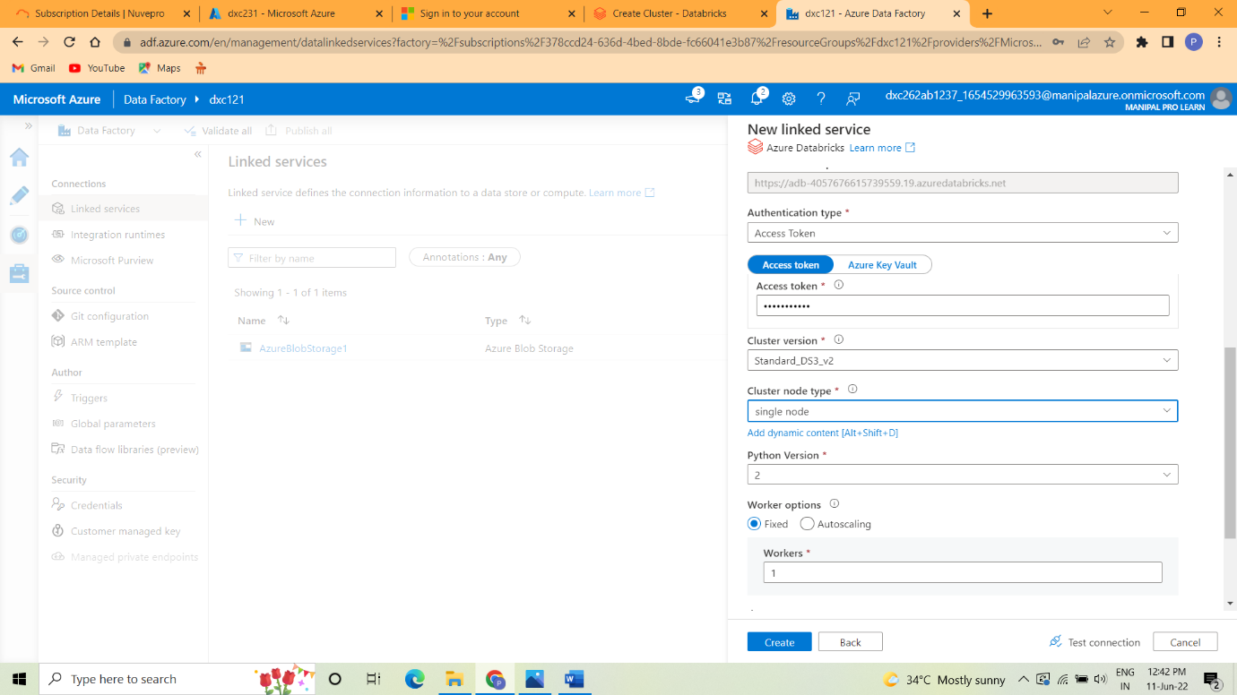

Step 6:After clicking the create button the Azure data bricks is linked with ADF.

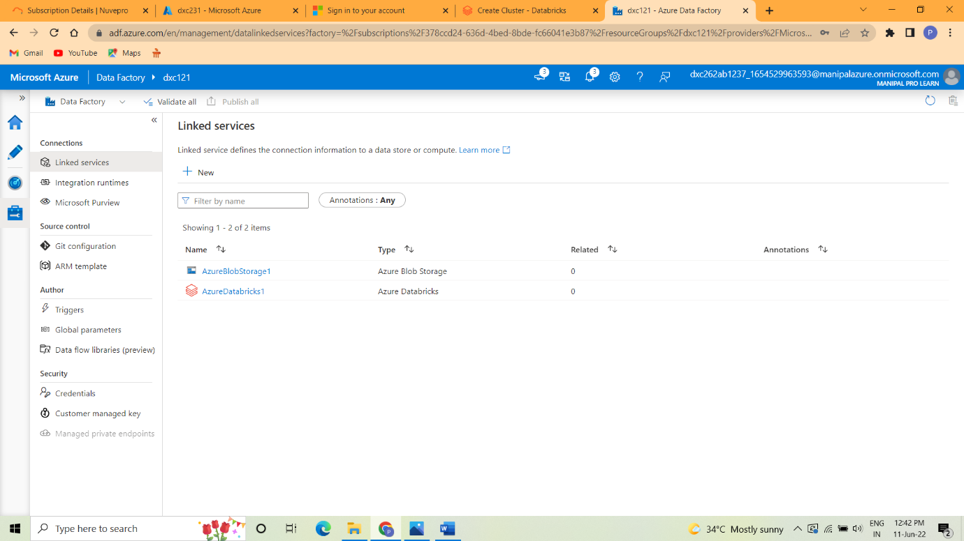

**Result:** In this project we successfully created the Azure Databricks and Azure Data Factory and also successfully implement the Business Logic.

**Conclusion:** In Azure Databricks the operations like creation of cluster and notebook and linked services are performed successfully.